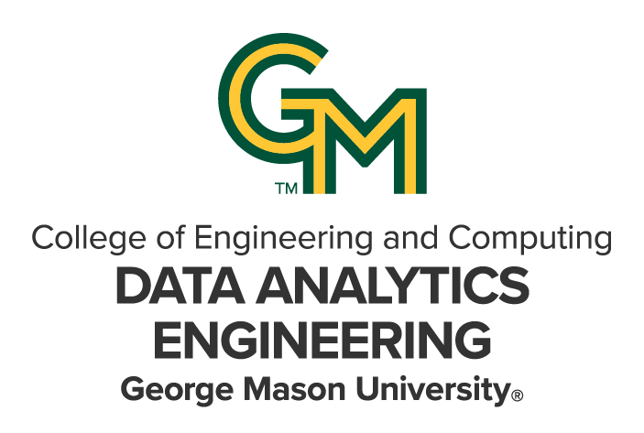

DAEN 690

Project Report

Adithi Kallem

Haripriya Kanuganollu

Gayathri

Bhargavi Mardala

Mahisa Sanofer Mohamed Shafiullah

Fall 2024

GMU Mason Student Services Center (MSSC) Generative AI Chatbot — 6-Month Pilot

**About the Cover**

James Baldo is an associate professor and serves as the Director of the George Mason University (GMU), College of Engineering and Computing (CEC), Volgenau School of Engineering (VSE), MS Data Analytics Engineering (DAEN) program. Dr. Baldo has served in this position since Fall 2018 and recently returned this past May after a 2-year sabbatical applying state-of-the-art data analytics engineering concepts and technologies to solve real world problems.

Prior to becoming director of the DAEN program he served 19 years as a CEC adjunct professor while working as a practicing engineer. His career has over 45 years of industry and government experience with roles as a data analytics engineer and software engineer.

His interest in large scale data, data management, analytics, and tools has provided him with opportunities to engage in assessing and applying new technologies across a diverse range of problems. The adoption of new technologies is exciting; however, adoption of new technologies requires careful planning and in addition to the technology, taking special care for planning how to successfully address for both organizational and cultural factors of the enterprise. This requires not only engineering knowledge and skills, but the ability to work on teams that interact across different corporate stakeholders.

Dr. Baldo continues to consult part-time with industry and leverages this knowledge and experience as feedback to the DAEN program. With technology moving at a lightening pace and technology adoption rates increasing, Dr. Baldo closely monitors the skillset needs of industry and how the DAEN program can provide graduates to fulfill these needs.

Dr. Baldo is currently researching applications of data mesh and data fabric for data management and exploring how analytics will be integrated into agentic systems.

Contents

Table of Contents

1 Introduction 3

1.1 Report Purpose 3

1.2 Report Readership 3

1.3 Report Structure 3

2 Datasets 4

2.1 Problem Space 4

2.1.1 Introduction 4

2.1.2 Objectives 5

2.1.3 Scope and Objectives 5

2.1.4 Stakeholders 6

2.1.5 User Requirements 7

2.1.6 Technical Requirements 8

2.1.7 Cost estimation for the 15-week Capstone Project 8

2.1.8 Timelines and Milestones 9

2.1.9 Validation and Success Criteria 9

2.1.10 Communication Plans 10

2.2 Research 10

Amazon Kendra: Data Crawling and Indexing Capabilities 10

Amazon DynamoDB 11

NLP and Generative AI RAG Chatbot 11

Retrieval-Augmented Generation 11

Large Language Models (Anthropic Claude) 12

No-Code/Low-Code Development 12

AWS Architecture 13

Testing and Evaluation Plan 14

2.3 Solution Space 14

2.3.1 Existing System 14

2.3.2 Proposed System 15

2.4 Project Objectives 16

2.5 Primary User Stories 16

2.6 Product Vision 17

**2.6.1** **Scenario #1** 17

**2.6.2** **Scenario #2** 17

3 Datasets 18

3.1 Overview 18

3.2 Field Descriptions 19

3.3 Data Context 19

3.3.1 Data Source 19

3.3.2 Data Collection 20

3.3.3 Data Description 20

3.4 Data Conditioning 20

3.4.1 IAM Roles and Security Configurations 21

3.4.2 Cloudformation Templates and Infrastructure 21

3.4.2.1 QNABOTPLUGIN-BEDROCK-EMBEDDINGS-AND-LLM 22

Content Designer 27

3.5 Data Quality Assessment 38

3.6 Other Data Sources 39

3.7 Storage Medium 39

3.8 Storage Security 39

3.9 Storage Costs 39

4 Implementation 40

4.1 Solution Approach 40

**4.1.1** **Systems Architecture** 40

**4.1.2** **Systems Security** 41

**4.1.3** **Systems Data Flows** 41

**4.1.4** **Algorithms and Analysis** 41

**4.1.5** **Prompt Engineering** 42

Testing and Validation of the chatbot 44

**Iterative Testing** 44

**Contextual Query Testing** 45

**Negative Testing** 45

Validation 45

Evaluation Criteria and Metrics 45

**Validation of chatbot responses** 46

**Chatbot User Guide for testing.** 46

5 Findings 52

6 Summary 53

6.1 Cost Breakdown: 54

7 Future Work 55

7.1 Alignment with GMU’s Evolving AI Strategy 55

7.2 Proposed Next Steps for the Chatbot’s Development 56

Appendix A: Domain Background 59

Appendix B: Glossary 62

Appendix C: GitHub Repository 63

Overview 63

GitHub Repository Link 63

GitHub Repository Contents 63

Appendix D: Risks 64

Sprint 1 Risks 64

Sprint 2 Risks 65

Sprint 3 Risks 65

Sprint 4 Risks 66

Sprint 5 Risks 66

Appendix E: Agile Development 67

Scrum Framework Team Approach 67

Sprint 1 Lessons Learned 67

Sprint 2 Lessons Learned 68

Sprint 3 Lessons Learned 68

Sprint 4 Lessons Learned 68

Sprint 5 Lessons Learned 68

Works Cited 71

Table of Figures

Figure 1: RAG Architecture…………………………………………………………………………………………………………………………………

Figure 2: ChatGPT is the latest Natural Language Processing tool for Data Analytics. 5

Figure 3: Data Analytics Engineering has the power to be transformative for an organization. 6

Figure 4: MSSC Chatbot Content Flow and Integration………………………………………………………………………………………..

Figure 5: New Architecture for 6-Month Pilot Setup……………………………………………………………………………………………

Table of Tables

Table 1: Glossary Table 18

Table 2: Sprint 1 Risks 20

Table 3: Sprint 2 Risks 21

Table 4: Sprint 3 Risks 21

Table 5: Sprint 4 Risks 22

Table 6: Sprint 5 Risks 22

**This page intentionally left blank**

Abstract

This project established the groundwork for a six-month pilot of a Generative AI Chatbot aimed at enhancing student support services at the Mason Student Services Center (MSSC) at George Mason University (GMU). Results from the Spring 2024 project highlighted the need for a scalable solution to provide 24/7 support, addressing gaps in MSSC’s availability during off-hours and periods of high demand. In preparation for the pilot, key architectural updates were implemented, including integrating the advanced Claude 3.5 Sonnet language model, reindexing the MSSC knowledge base using Kendra to ensure updated and relevant responses, and refining prompt engineering to enhance the chatbot’s contextual understanding and accuracy. While automated testing tools were initially considered for evaluating response quality, they were deemed unsuitable for this project, leading to the development of a manual testing framework that assessed the chatbot’s accuracy, relevance, and sensitivity to user emotions. Testing also included handling ambiguous or misleading queries and ensuring adherence to privacy standards. At the conclusion of the project, the updated chatbot system, along with supporting documentation for maintenance and upgrades, will be handed over to MSSC and ITS for the implementation of the six-month pilot, paving the way for improved accessibility and efficiency in student services through advanced AI solutions.

**This page intentionally left blank**

Report

1. Introduction

1.1 **Report Purpose**

This report lays the groundwork for a six-month pilot project in partnership with the Mason Student Services Center (MSSC) to deploy an advanced Generative AI RAG chatbot. The project aims to integrate the latest Anthropic Claude LLM, update the MSSC knowledge base, and thoroughly test the chatbot’s response quality and effectiveness. The goal is to streamline MSSC operations, enhance student experience, and meet the growing demand for reliable, 24/7 support services. This report documents the work performed to achieve these objectives and ensure the successful deployment of the AI RAG chatbot during the pilot phase.

1.2 **Report Readership**

This report is intended for the Mason Student Services Center (MSSC) staff. The MSSC staff will use this report to assess the AI RAG Chatbot’s performance during the six-month pilot, focusing on the accuracy and effectiveness of its responses to student inquiries.

Meanwhile, the technical team will use this report to oversee the pilot’s implementation and ensure it aligns with university AI practices. They will address the technical aspects of the six-month pilot, including resolving any policy-related issues at both institutional and departmental levels. This report serves as a clear framework for both MSSC and the technical team to coordinate their responsibilities and expectations throughout the pilot phase.

1.3 Report Structure

This report begins with an Abstract that offers a high-level overview of the project. Section 1: Introduction outlines the report’s purpose, intended audience, and structure. Section 2: Problem Definition describes the challenges faced by the Mason Student Services Center (MSSC), the research conducted, proposed solutions, project objectives, and user stories. Section 3: Datasets focus on the MSSC knowledge base articles, detailing their structure, storage, and security measures. Section 4: Solution Approach explains the Workflow and System Architecture, showing how the AI chatbot integrates with existing systems and processes. Section 5: System Deployment and Testing covers the groundwork for the six-month pilot program, replacing the typical model training and evaluation section. The concluding sections include Findings, Summary, and suggestions for Future Work, along with appendices that contain a Glossary, Risks, and insights into Agile Development practices used throughout the project. This structure ensures a comprehensive view of the project, aligning with the specific scope and focus areas of our groundwork for the six-month pilot MSSC AI RAG Chatbot.

1. Datasets
   1. **Problem Space**
      1. **Introduction**

The Mason Student Services Center (MSSC) is the central hub for information and solutions related to registration, enrollment, financial aid, billing, academic records, and other student support services. By assisting a team of cross-trained representatives, the MSSC eliminates the need for students to visit multiple offices on campus, offering a more streamlined and efficient support experience. However, the growing demand for reliable, 24/7 support services has highlighted the need for advanced solutions that can operate continuously and manage a high volume of inquiries.

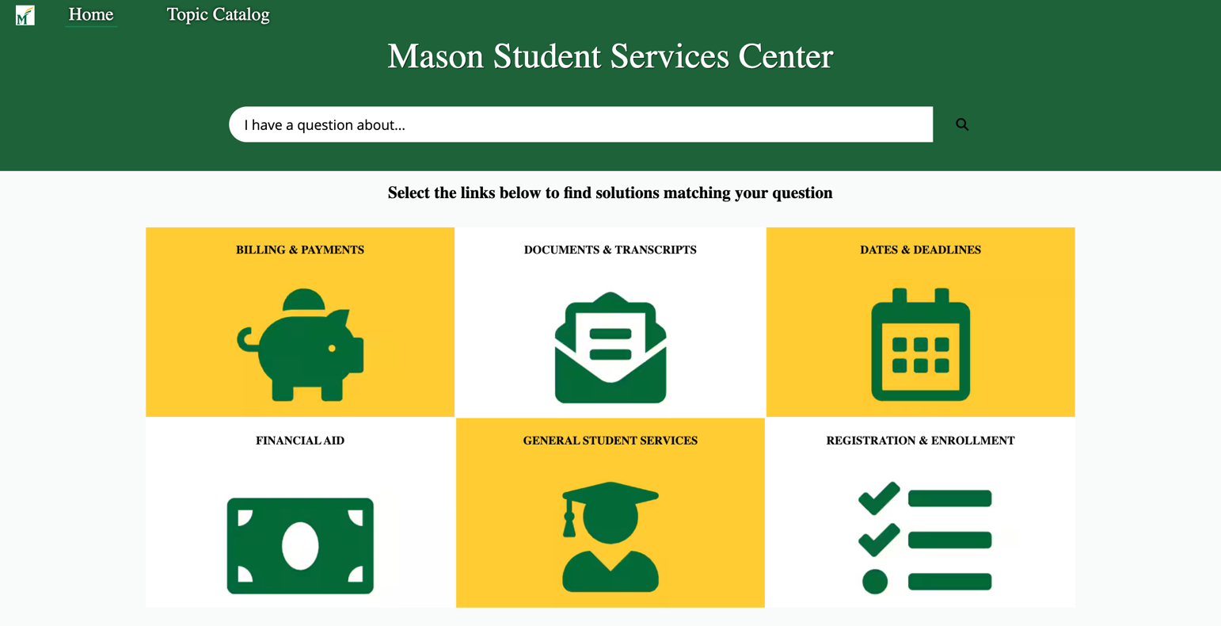

From September 15, 2023, to September 15, 2024, the MSSC handled a substantial volume of interactions: 14,741 in-person visits, 57,880 web form submissions, and emails, 97,894 phone calls, and 45,809 cases originating from partner offices but managed by MSSC. This high volume underscores the necessity for AI-based solutions to efficiently manage and streamline these interactions.

In Spring 2024, proof of concept using the AWS QnAbot was developed to demonstrate the potential of AI-based solutions. Building on this foundation, we are now preparing for a 6-month pilot to deploy AI RAG chatbots. This project aims to lay the groundwork for this pilot in collaboration with the MSSC. The pilot will focus on integrating the latest language models, such as Anthropic Claude, updating the search index with new MSSC knowledge base articles.

These chatbots are designed to provide immediate, accurate responses to student queries at any time of day. By leveraging the latest advancements in Generative AI and Retrieval-Augmented Generation (RAG) techniques, the chatbots will be integrated with the MSSC knowledge base to ensure that students receive the most current and relevant information. This initiative aims not only to enhance the student experience but also to streamline MSSC operations, allowing staff to focus on more complex and high-priority tasks. The successful deployment of this AI RAG chatbot will mark a significant step forward in the use of AI to improve university support services, setting a precedent for future innovations in this area.

* + 1. **Objectives**

The primary goal of the 6-month pilot is to enhance the AI RAG chatbot's capabilities by upgrading it with the latest version of the Anthropic Claude LLM, aiming to significantly improve its ability to understand and generate relevant, contextually appropriate responses. By integrating the most advanced natural language processing (NLP) technology, the chatbot will be better equipped to handle complex student inquiries, providing more accurate and context-aware responses.

A key component of the pilot is updating the chatbot’s search index with new knowledge base articles from the Mason Student Services Center (MSSC). This update ensures that the chatbot remains aligned with the latest information on student services, academic programs, policies, and other crucial university-related topics. As a result, students will receive the most current and relevant information, which is vital for maintaining the chatbot’s utility and effectiveness.

The project also includes extensive testing and evaluation of the chatbot’s response quality and overall performance. This will involve assessing how well the chatbot addresses a variety of student inquiries, from basic questions to more complex, multi-part queries. The evaluation process will focus on determining how accurately and effectively the chatbot handles these different types of interactions, identifying any areas where its responses can be improved. This will include manual testing, performance tracking, and gathering user feedback to inform future updates and refinements.

Overall, the objectives of the 6-month pilot focus on optimizing the chatbot’s functionality, improving its knowledge base, testing its capabilities, and ensuring its performance aligns with the needs of GMU’s students and staff. These efforts will lay a solid foundation for the successful scaling of the AI RAG chatbot, ensuring that it can meet the long-term needs of students and other users at GMU.

* + 1. **Scope and Objectives**

The scope of the 6-month pilot project is primarily focused on integrating the AI RAG chatbot with the Mason Student Services Center (MSSC) knowledge base. Over the course of the pilot, the chatbot will be tested with a specific set of data, which will be drawn exclusively from the MSSC website. The chatbot’s ability to provide relevant responses will be based on this limited dataset, and additional data sources, such as current Salesforce case tickets, will not be included within the scope of the pilot.

The chatbot will be designed to handle text-based queries only during the pilot phase. It will not support speech input, nor will it accommodate multiple languages. These limitations will ensure a controlled environment for testing and evaluation, providing clear insights into the chatbot’s capabilities within the scope of the defined project parameters.

During the knowledge indexing process, the Kendra search engine will be restricted to only include links from GMU’s official sources. This means that any external sources, including third-party websites or non-GMU-related content, will be excluded from the chatbot's knowledge base, ensuring that responses are relevant to the university’s student services.

To ensure the chatbot continues to provide accurate and timely information, regular updates to its search index with the latest MSSC knowledge base articles will be required. These updates will maintain the accuracy and relevancy of the chatbot’s responses, particularly as student services and university-related content evolve.

Finally, the scope of the chatbot’s functionality during this pilot phase will be deliberately limited. While the chatbot will focus on handling text-based queries and utilizing the MSSC knowledge base, the development of additional features or integrations, such as support for other data sources or advanced capabilities, will be considered in future phases. These additional features will be assessed based on the outcomes of the pilot, including user feedback and performance evaluations.

* + 1. **Stakeholders**

The stakeholders in this project are critical to the successful development, implementation, and long-term sustainability of the Generative AI Chatbot at the Mason Student Services Center (MSSC). These stakeholders include both internal staff from MSSC and external stakeholders from the Information Technology Services (ITS) department. Each group plays a key role in ensuring the chatbot's effectiveness, relevance, and integration within the broader ecosystem of student services at George Mason University.

The MSSC staff are the primary users and benefactors of the chatbot. They oversee the operations and management of student services, addressing a wide range of student inquiries related to admissions, registration, financial aid, housing, and other student-related services. As the chatbot is designed to assist in handling routine queries, the MSSC staff are directly involved in defining the requirements and expectations for the chatbot’s functionality. Their input is essential in shaping the knowledge base to ensure that it accurately reflects the policies, processes, and services provided by MSSC. Furthermore, MSSC staff are key in identifying areas where the chatbot needs improvement, particularly in handling complex or ambiguous questions that may require human intervention. In addition, the ongoing training and updating of the chatbot's knowledge base will depend heavily on MSSC staff to ensure the chatbot’s responses are always relevant and up-to-date.

ITS plays a critical role in the technical aspects of the project. As the department responsible for managing the university's IT infrastructure, ITS provides the necessary support for integrating the chatbot with existing systems and ensuring its smooth operation. ITS is responsible for ensuring that the chatbot can scale effectively and securely handle the data it processes, including student inquiries and interaction histories. ITS is also instrumental in ensuring that the chatbot is compatible with GMU’s technology stack and adheres to university-wide standards for privacy, security, and data protection. In addition, ITS provides support for integrating the chatbot with other systems across the university, which may include connecting the chatbot to other student services, databases, and platforms that could be useful for providing comprehensive and accurate responses to students.

While the primary stakeholders in this project are the MSSC staff and ITS, other university departments may also be indirectly involved. This includes departments that provide content for the knowledge base, such as Admissions, Financial Aid, Housing, and other student services departments. These stakeholders are important for ensuring that the chatbot is continually updated with relevant information and that any changes in policies or services are reflected in the chatbot’s responses. Collaboration between departments will also be essential as the chatbot evolves to cover a broader range of student services.

Although not directly involved in the development or management of the chatbot, students are the ultimate end-users of the system. Their feedback and usage patterns will be vital for refining the chatbot’s performance and ensuring it meets their needs. The chatbot’s success depends on students' ability to use it effectively and find the information they need. As such, gathering insights from students about their experience with the chatbot will be important for future iterations, ensuring that the chatbot continues to meet the evolving needs of the student body.

By engaging with these stakeholders throughout the development and deployment of the chatbot, the project can ensure that the solution meets the requirements of the MSSC, integrates seamlessly with ITS infrastructure, and ultimately delivers value to students. Collaboration among stakeholders is essential for the successful implementation and scalability of the chatbot, enabling it to improve the efficiency and accessibility of student services at George Mason University.

* + 1. **User Requirements**

During the 6-month pilot phase, the AI Retrieval-Augmented Generation (RAG) chatbot is designed to cater to a diverse range of users, including GMU students, staff, alumni, non-Mason students, and external individuals seeking information about the university. The primary objective is to ensure the chatbot provides timely, accurate, and relevant responses to a wide variety of inquiries, ranging from academic programs and admissions to student services and general university information.

To meet these needs, the chatbot must deliver responses that are not only accurate but also timely. It should be able to address different user queries in a quick and precise manner, tailored to the context of the user—whether they are a current student, a prospective student, or an alumni.

A key aspect of the system is its user-friendly interface. The chatbot needs to be intuitive and easy to navigate, ensuring that all users, including those with limited technical expertise, can access the information they require without difficulty. The design should be simple yet effective, supporting a smooth and seamless experience on a variety of devices, such as smartphones and laptops.

In addition to usability, the chatbot's knowledge base must be regularly updated to provide the most current and relevant information. This is crucial for maintaining accuracy, especially as university services, policies, and programs evolve over time. The system must be able to incorporate these updates efficiently, ensuring users always receive up-to-date information.

The chatbot also needs to leverage advanced natural language processing (NLP) capabilities to handle a wide range of queries, including complex and multi-part questions. This will allow it to better understand and respond to varied user inputs, even when questions are ambiguous or incomplete.

Lastly, the system must ensure that all user interactions comply with GMU's privacy policies, safeguarding personal data in accordance with relevant regulations. This security and privacy consideration is essential for maintaining trust and protecting sensitive information throughout the chatbot's use.

By meeting these requirements, the AI RAG chatbot will be well-equipped to support GMU's diverse user base, providing valuable assistance during the pilot phase and setting the stage for future full-scale implementation.

* + 1. **Technical Requirements**

The technical requirements for the 6-month pilot project are designed to ensure the successful integration and performance of the AI RAG chatbot within the GMU ecosystem. The following are the key technical aspects:

1. **AWS Cloud Services**: The pilot will leverage various AWS cloud services to build and deploy the chatbot. Services such as Amazon Kendra, Bedrock, Lambda, Lex, Parameter Store, Cognito, and API Gateway will be used to power the chatbot’s search capabilities, handle interactions, and manage secure access. These services will enable the chatbot to operate efficiently and scale according to demand.
2. **Regular Knowledge Base Updates**: The chatbot’s search index will need to be updated regularly with the latest MSSC knowledge base articles. This will ensure that the chatbot can provide accurate, up-to-date information for users, especially as the university’s resources and services evolve.
3. **Anthropic Claude LLM Upgrade**: The AI RAG chatbot will be upgraded to the latest version of the Anthropic Claude LLM, enhancing its ability to understand and respond to queries with greater accuracy and relevance. This upgrade is crucial to improving the chatbot’s overall performance and ensuring it can handle a wide variety of student inquiries.
4. **Low Code/No Code Solutions**: To streamline the development and deployment processes, the project will incorporate low code/no code solutions. These tools will allow for quicker adjustments, reduced complexity, and easier integration with existing systems, enabling the team to focus on higher-level tasks and ensuring the chatbot is deployed within the project timeline.
5. **AWS Account Management**: The pilot will be executed within an AWS account provided by the GMU College of Engineering and Computing (CEC). This account will serve as the platform for deploying and managing all technical components of the chatbot system, ensuring proper alignment with GMU’s infrastructure standards.
6. **AWS Account Management Support**: Dan O’Brien, a member of the CEC IT support team, will be responsible for managing the AWS accounts, ensuring proper configuration, security, and resource allocation throughout the pilot period. His role is critical in maintaining the stability and scalability of the system.
7. **Support from MSSC**: Kimberly Shumadine and Andrew Bunting from the MSSC will provide crucial support in understanding and managing the MSSC knowledge base. Their involvement will ensure that the chatbot has access to accurate and up-to-date information from the university’s student services, facilitating effective responses to user queries.
   * 1. **Cost estimation for the 15-week Capstone Project**

The cost estimation for the 15-week Capstone Project provides an overview of the daily average expenses associated with multiple Amazon Web Services (AWS) components and AI model usage. Key AWS components supporting the project include Amazon API Gateway, Cognito, S3, EC2, Lambda, and Kendra, with pricing influenced by factors such as API call volume, active user count, data transfer rates, and request durations.

The AI chatbot component, integral to the 6-month pilot project, incurs costs based on query handling and service utilization. Amazon Kendra, a central service for search functionality, represents a significant portion of the expenses, with the Developer edition’s pricing based on document storage, query volume, and indexed data sources. Current daily costs for Kendra average around $27, making it the largest single expense in the system.

In addition to Kendra, OpenSearch and EC2 contribute daily costs of approximately $1.80 and $1.08, respectively, with EC2 supporting the underlying computer infrastructure for chatbot operations. CloudWatch, SecurityHub, Key Management, and GuardDuty add essential costs for monitoring, security, and compliance. Additionally, Anthropic’s Claude models used for chatbot interactions (e.g., Claude 3.5 Sonnet and Claude 2.1) are billed based on token usage for processing and generating responses, with typical daily costs ranging from $0.003 to $0.15. Even when the service is not in active use, a minimum charge of $27 still applies. This base fee is incurred regardless of usage to cover essential maintenance and availability.

The cost breakdown for the 15-week period includes expenses for four weeks in September, five weeks in October, four weeks in November, and two weeks in December. Based on an average daily cost of $26 to $32, the total estimated cost for this period is approximately **$3,055**. This figure highlights the financial requirements for maintaining the AI and web services essential to the pilot phase, underscoring the importance of services like Kendra and OpenSearch in enabling robust search and data retrieval capabilities.

* + 1. **Timelines and Milestones**

The project timeline for the 6-month AI RAG chatbot pilot is structured into five sprints, each marking a significant milestone. Sprint 1 focuses on problem definition and initial setup, including defining objectives and setting up the AWS environment. Sprint 2 involves data collection and preparation, where datasets from the MSSC knowledge base are crawled using Kendra, with web scraping and indexing implemented. Sprint 3 covers implementation and development, integrating the AI RAG chatbot with AWS services, implementing NLP techniques, and upgrading to the latest Anthropic Claude LLM. Sprint 4 is dedicated to testing and refinement, ensuring thorough testing of the chatbot’s functionality and making necessary optimizations based on feedback. Sprint 5 involves compiling the final report and preparing for the showcase presentation on December 9. Each sprint is meticulously planned with specific deliverables to ensure continuous development and enhancement of the project.

* + 1. **Validation and Success Criteria**

The 6-month pilot of the AI RAG chatbot will involve evaluating its performance based on specific validation and success criteria. The chatbot will be deployed to retrieve information from the student services website and provide summarized responses in natural language. Professor Bernard Schmidt will oversee the validation process to ensure that the chatbot meets the required standards for deployment and functionality.

The validation criteria will primarily focus on two key areas:

1. **Response Accuracy**: One of the primary measures of success will be the accuracy of the chatbot’s responses. The chatbot must achieve a minimum of 90% correctness in its answers to student inquiries. This will be assessed through rigorous testing scenarios involving various types of student queries, ensuring that the chatbot consistently provides accurate and relevant information.
2. **Natural Language Quality**: In addition to accuracy, the chatbot’s responses must maintain high-quality natural language, ensuring that they are clear, coherent, and easy to understand. The responses should sound conversational, in line with human-like interactions, while still being informative and concise.

These criteria will serve as the benchmarks for evaluating the chatbot’s success in meeting user needs and providing reliable assistance. Regular assessments and feedback will be used to refine the chatbot and address any gaps or areas for improvement, ensuring its readiness for wider deployment post-pilot.

* + 1. **Communication Plans**

Effective communication plays a vital role in the success of this project, particularly during the 6-month pilot phase. To ensure all stakeholders remain informed and engaged, a structured communication plan will be implemented. Regular updates will be provided to key stakeholders, including students, MSSC staff, and relevant teams within the university.

Progress reports will be shared on a scheduled basis, highlighting key developments, milestones, and any challenges encountered. These reports will ensure transparency and keep all parties aligned with the project's goals and timelines. Additionally, feedback from users will be actively collected throughout the pilot phase. This feedback will be crucial in identifying areas for improvement and refining the chatbot’s functionality to better meet user needs.

By maintaining open lines of communication, the project team aims to foster collaboration and ensure that necessary adjustments are made in response to real-time feedback. This approach will help in fine-tuning the chatbot’s performance, ensuring it delivers value to students and supports the long-term objectives of the Mason Student Services Center.

* 1. **Research**

**Amazon Kendra: Data Crawling and Indexing Capabilities**

Amazon Kendra is a highly efficient enterprise search service that powers advanced semantic search capabilities across various data sources. In this project, Kendra is employed to index knowledge articles from the Mason Student Services Center (MSSC) database, enhancing the chatbot’s ability to deliver accurate and relevant responses. Kendra can crawl data from multiple sources, such as websites, file systems, and document repositories, consolidating them into a single index. Its web-crawling process utilizes Selenium, an automated web-scraping tool, to ensure data is gathered from web pages in a timely and comprehensive manner.

Once the data is indexed, Kendra’s semantic search engine enables the chatbot to retrieve the most relevant documents based on user queries. The system ranks the documents by relevance and extracts the top 3 to 5, which are then scanned for the most appropriate passages. This process allows the chatbot to provide concise and contextually accurate answers, improving user interactions by delivering precise information without overwhelming the user with unnecessary content.

A major advantage of Amazon Kendra is its flexible data synchronization feature, which allows the index to stay up to date with minimal manual intervention. Kendra’s crawler can be scheduled to sync data on an hourly, daily, weekly, or custom basis to ensure the index reflects the latest knowledge base updates. With S3 event notifications or an S3 Bridge, Kendra can automatically sync new or modified articles. It supports both Incremental Sync, which updates only new, modified, or deleted content, and Full Sync, which refreshes the entire index to account for significant changes. This flexibility is crucial for the six-month pilot, ensuring the chatbot continuously operates with the most current and comprehensive data.

**Amazon DynamoDB**

Amazon DynamoDB is a fully managed, serverless NoSQL database service that scales automatically to meet the demands of high-scale applications, ensuring cost efficiency by charging only for what is used. Its serverless architecture eliminates the need for capacity planning and operational maintenance, while its 99.999% availability SLA and multi-region, multi-active replication through Global Tables provide high availability and resilience. DynamoDB also offers robust security features, including encryption, fine-grained access control, and compliance with industry standards, ensuring data protection and regulatory adherence.

For our AI RAG chatbot, we utilize DynamoDB to store user chat history and responses efficiently. The table schema includes a composite primary key with UserID and Timestamp, along with attributes like Message Content, Response Content, and Message Type. This setup supports efficient querying and retrieval of chat data, enhancing the chatbot’s functionality. Additionally, DynamoDB Streams enable real-time data processing, allowing us to build event-driven applications and maintain data integrity with managed backups and point-in-time recovery options.

**NLP and Generative AI RAG Chatbot**

One of the primaries focuses of our research was understanding the technologies behind the Generative AI RAG chatbot. The existing chatbot, which was developed during the Spring 2024 capstone project, uses retrieval-augmented generation (RAG) technology to combine a retrieval system with a generative model, improving the accuracy and contextual relevance of its responses. Our goal was to enhance this chatbot by integrating the latest version of the Anthropic Claude language model, known for its advanced comprehension and improved response generation capabilities. To accomplish this, we reviewed recent research papers and technical documentation on large language models, including their training processes and integration challenges with retrieval systems like Amazon Kendra. This research provided us with the knowledge needed to update the chatbot effectively while addressing potential issues related to handling complex or ambiguous queries.

**Retrieval-Augmented Generation**

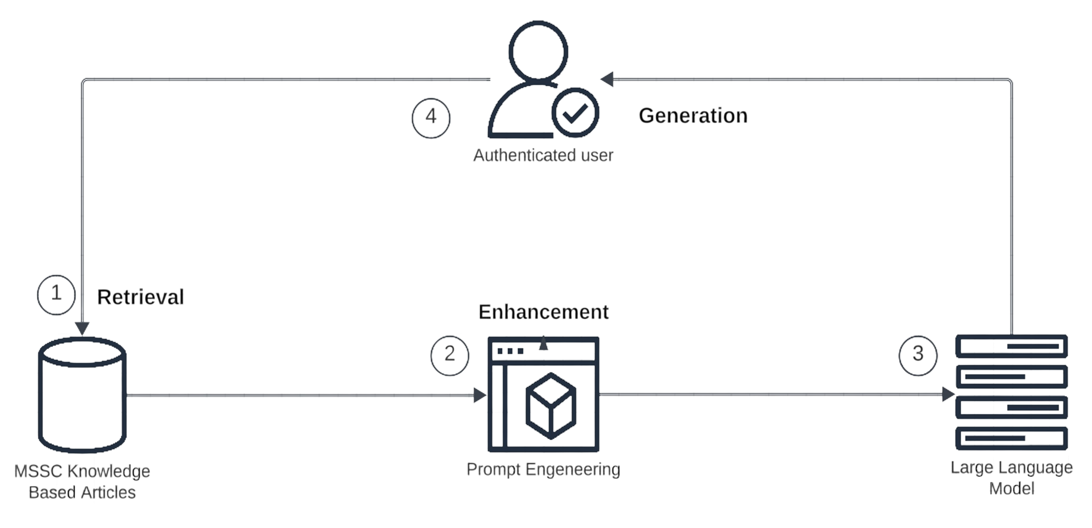

Figure 1: RAG Architecture

The Retrieval-Augmented Generation (RAG) architecture is central to the design of the generative AI chatbot used in this project. The goal of RAG is to combine the strengths of information retrieval with the generative capabilities of large language models (LLMs) to enhance the accuracy and relevance of responses in real-time applications, such as the chatbot at the Mason Student Services Center (MSSC).

In the RAG architecture, two main components work together: the retriever and the generator. The retriever’s job is to search an external knowledge base for relevant documents or information that can help answer the user's query. In the case of our chatbot, the knowledge base consists of updated MSSC articles, which are crucial for providing accurate and current information about student services. The retriever uses dense retrieval methods, such as embedding-based search, to find and rank the most relevant documents based on the user's input.

Once the retriever gathers relevant documents, the generator processes them along with the user's original query. The generator, which is typically a pre-trained language model like Anthropic's Claude, takes the retrieved information and generates a coherent, contextually appropriate response. This allows the chatbot to leverage not just the model's pre-trained knowledge, but also the up-to-date information retrieved from the MSSC knowledge base, ensuring that the chatbot can provide accurate and specific answers to a wide range of student-related inquiries.

The strength of the RAG architecture lies in its ability to integrate external knowledge into the generation process. By combining retrieval and generation, the system can provide more informed and relevant responses, even to questions that may not have been part of the training data. This is particularly important for dynamic environments like MSSC, where the information needs to be regularly updated to reflect the latest policies, procedures, and services available to students.

In the context of this project, RAG plays a critical role in ensuring that the chatbot is both accurate and adaptable, able to handle a variety of questions by referencing real-time data from the knowledge base. As the system evolves and the knowledge base continues to grow, the RAG architecture will be essential for maintaining the chatbot's relevance and effectiveness in addressing student needs.

**Large Language Models (Anthropic Claude)**

One of the critical areas of focus was the integration of the latest version of the Anthropic Claude language model. The chatbot’s architecture was initially based on a retrieval-augmented generation (RAG) model, which combines a retrieval system with a generative model. Our task is to enhance the chatbot using the latest advancements in large language models (LLMs), specifically Anthropic Claude, known for its superior comprehension and response generation. Our research involved reviewing technical papers and documentation on Anthropic Claude, exploring its architecture, training methods, and how it can be integrated with AWS components like Amazon Kendra for enhanced information retrieval. This deep dive into LLMs helped us plan for an efficient upgrade of the chatbot to improve response accuracy and user experience.

**No-Code/Low-Code Development**

In addition to the chatbot’s underlying AI technologies, we explored no-code and low-code development platforms to determine whether they could be leveraged to enhance the project. While the core of the project relies on AWS services, we researched the potential use of no-code/low-code solutions to simplify specific tasks, such as testing and front-end development. Although we ultimately did not implement these platforms in the current phase, understanding their capabilities allowed us to consider future opportunities for reducing development time and increasing accessibility for non-technical users. Our research into these tools also involved consulting technical literature and online resources to explore their potential role in conversational AI systems.

**AWS Architecture**

A significant part of our research centered around the AWS services that form the architecture of the chatbot. The core framework for the project is based on AWS QnABot, which is used for building conversational AI. We researched the interaction of several AWS services, including Amazon Lex for natural language understanding, Amazon Kendra for intelligent search, Amazon Bedrock for large language models, and AWS Lambda for scalable computation. To better understand how these services integrate and how they can be customized to meet our specific needs, we delved into AWS documentation and studied best practices shared on technical forums. This research was crucial for optimizing the architecture, ensuring the chatbot can handle queries efficiently and integrate with the latest language models.

In conclusion, our research encompassed a broad range of areas crucial to the success of the project, from enhancing the RAG chatbot with the latest technologies to ensuring compliance with governance frameworks and optimizing AWS services for performance. This research provides the foundation needed to move forward with implementing and testing the updated chatbot in preparation for the 6-month pilot phase.

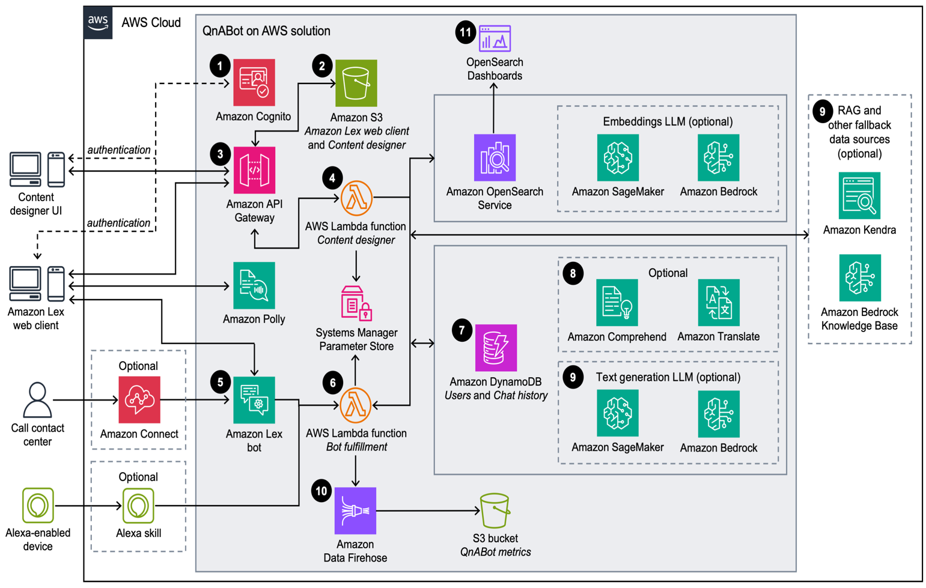

Figure 2: AWS QnABot Reference Architecture

**Testing and Evaluation Plan**

The Generative AI RAG chatbot's performance will be assessed through a comprehensive manual testing and evaluation plan, focusing on iterative testing, contextual query testing, and negative testing.

**Iterative Testing:** Continuous cycles of testing and feedback analysis will help identify and resolve issues such as incomplete responses or inconsistencies, enabling incremental improvements in the chatbot's functionality and robustness. Prompts will be refined after each cycle to ensure enhanced response quality and user satisfaction.

**Contextual Query Testing:** This evaluates the chatbot’s ability to handle multi-turn conversations, maintaining context for coherent and user-friendly interactions. Testing ensures that the chatbot can recall previous context to deliver relevant and seamless responses, especially for follow-up queries or complex scenarios.

**Negative Testing:** Focuses on the chatbot’s ability to handle ambiguous, incomplete, or invalid inputs gracefully. The goal is to ensure the chatbot provides helpful guidance or prompts users to rephrase queries, preventing crashes or irrelevant responses while maintaining a smooth user experience.

* 1. **Solution Space**
     1. **Existing System**

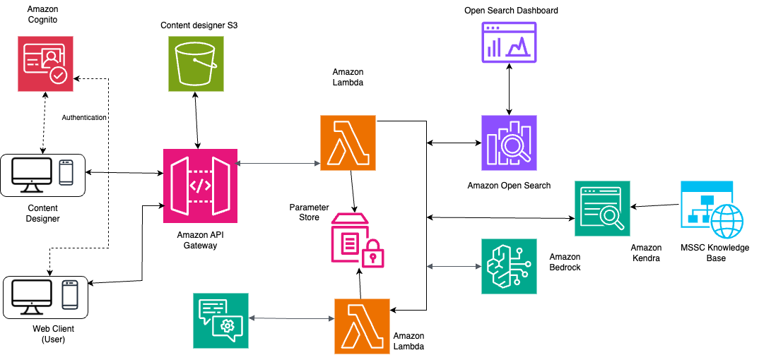

Figure 3: Existing Chatbot Architecture

The MSSC knowledge base is currently maintained within Salesforce Knowledge, with MSSC staff manually adding or updating articles. These articles are then published on the MSSC website, which serves as the system of record since the project team does not have direct access to Salesforce Knowledge. The Spring team integrated this knowledge base into a chatbot system, creating a proof-of-concept that allows users to submit queries to the chatbot. The chatbot retrieves the most relevant responses from the MSSC knowledge base using an Amazon Kendra index populated through a web crawler. To enhance functionality, OpenSearch Dashboards were integrated for improved search analytics, and Anthropic Claude 3 FFM in AWS Bedrock was utilized for processing and analyzing user queries.

* + 1. **Proposed System**

The proposed chatbot system, designed for a 6-month pilot setup, leverages several key AWS components to enhance user interaction with the MSSC knowledge base. Amazon Lex initiates the process by capturing user queries, which are then processed through a Lambda function and the RAG (Retrieval-Augmented Generation) component. This component retrieves relevant documents from the MSSC website via the Amazon Kendra index, ensuring efficient access to updated information.

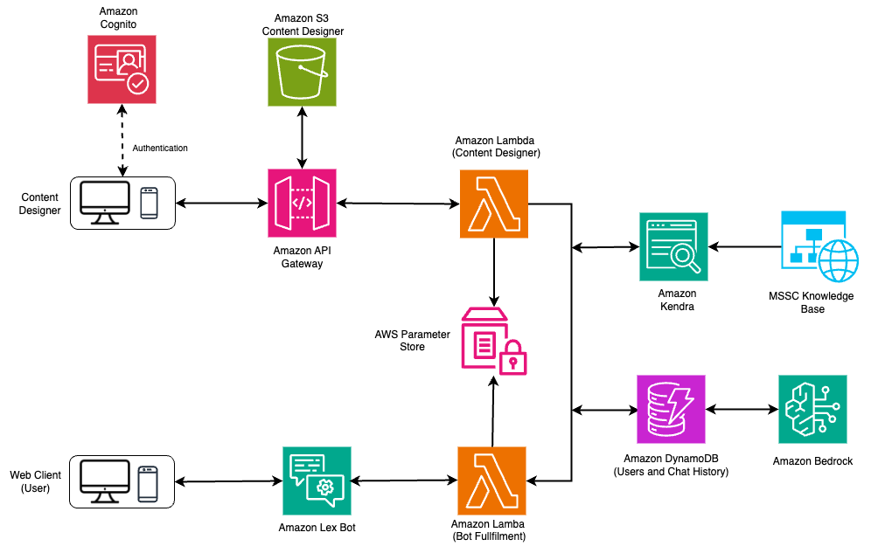

Figure 4: New Architecture for 6-Month Pilot Setup

A significant new addition is Amazon DynamoDB, which plays a crucial role in storing user queries and responses. This allows the chatbot to maintain a history of interactions, enabling context-aware and personalized responses, unlike traditional stateless web applications. The decision to remove OpenSearch was made because it primarily supported a Q&A bot without generative AI capabilities, functioning mainly as a FAQ tool. By focusing on DynamoDB and other AWS services, the system becomes more streamlined and efficient. Additionally, the Content Designer interface empowers authorized developers to configure the system easily without the complexity of a custom web client or intricate authentication mechanisms.

* 1. **Project Objectives**

The project’s major goal is to lay the groundwork for a 6-month pilot Generative AI RAG chatbot by integrating advanced AI technologies, assuring compliance with governance frameworks, and optimizing the system. By the end of the research, the team hopes to have gained a better knowledge of how to properly incorporate important AI technologies like Amazon Lex, Amazon Kendra, and the Anthropic Claude LLM into a conversational AI system. The team will also acquire practical experience in designing and deploying Retrieval-Augmented Generation (RAG) tools to improve student services at GMU’s Mason Student Services Center (MSSC). This involves investigating the capabilities and limits of various technologies and adapting them to fit MSSC’s unique requirements.

Furthermore, the team plans to release a fully functional Generative AI RAG chatbot, upgraded with the latest AI technologies. These enhancements include the integration of the Anthropic Claude LLM and expanded search capabilities with Amazon Kendra. The solution will undergo thorough testing and fine-tuning to address a wide range of concerns, ensuring it provides students with accurate, timely, and consistent service continuously. Ultimately, the chatbot will significantly enhance the MSSC’s operational effectiveness by offering round-the-clock support to students.

By the project’s conclusion, the team aims to better understand the challenges of automating student services using AI-driven solutions. This includes addressing the technical challenges of scaling the solution to manage diverse student inquiries and navigating the complexities of aligning AI technologies. The team will also explore the ethical and practical implications of deploying AI chatbots to ensure the solution is both effective and compliant with established standards.

The outcome of this project will bring substantial value to both GMU and the broader community. For GMU, the chatbot will enhance student support services by providing 24/7 assistance, thereby reducing staff workload and improving student satisfaction. Beyond the university, the project will serve as a model for how educational institutions and other organizations can leverage AI and cloud technologies to modernize their service operations while adhering to ethical and governance standards. The operational documentation produced during the 6-month pilot will serve as a valuable resource for future teams, potentially extending the chatbot’s functionality and reach in subsequent phases.

Through the completion of this project, the team anticipates not only achieving technical success but also contributing to the ongoing conversation about the role of AI in higher education and administrative services.

* 1. **Primary User Stories**

These are the Primary User Stories:

* As an MSSC staff member, I want to use the 6-month pilot AI RAG chatbot to manage routine student inquiries so that I can focus on complex issues, ensuring students receive timely assistance without overwhelming our staff.
* As an IT administrator, I want to ensure that the AI RAG chatbot integrates seamlessly into our existing systems during the 6-month pilot phase and is consistently updated with the latest MSSC knowledge base information to deliver accurate and up-to-date responses to student queries.
* As a user seeking assistance from the Mason Student Services Center, I want to access the 6-month pilot RAG Generative AI chatbot through a web browser to quickly find accurate information about admissions, academic advising, and financial aid so that I can resolve my questions independently and efficiently, without having to rely on support staff or be constrained by office hours.
  1. **Product Vision**

The vision for the Generative AI RAG Chatbot project is to provide a robust, efficient, and solution that significantly enhances student services at GMU by offering 24/7 assistance, reducing delays, and improving operational efficiency. This chatbot will ensure that students receive accurate, timely, and consistent responses to their queries through an intuitive and reliable interface.

For: GMU students, staff, and the public

Who: Require quick, accurate, and round-the-clock access to information related to admissions, academic advising, financial aid, and other services

The: Generative AI RAG Chatbot

Is a: Web-based AI-driven chatbot that uses advanced large language models (LLMs) like Anthropic Claude, and search capabilities powered by Amazon Kendra

That: Provides instant responses to student queries, automates routine tasks, and enhances the accessibility of student services

Unlike: Traditional service models that rely heavily on staff availability during office hours

Our product: Is accessible 24/7, provides accurate responses using an updated knowledge base, and meets governance standards

Caveats: The system is currently limited to web browsers, with no mobile or Alexa integrations. Additionally, initial response accuracy depends on the quality and completeness of the knowledge base.

### **Scenario #1**

A student logs into the GMU student portal late in the evening with questions about upcoming registration deadlines and financial aid application status. Normally, the student would have to wait until the next day to contact a staff member or navigate through long FAQ pages to find an answer.

With the Generative AI RAG Chatbot, the student interacts with the chatbot, which processes the inquiry using Amazon Lex, accesses the latest information from the MSSC knowledge base through Amazon Kendra, and provides an accurate response within seconds. The student receives all the necessary details, updates their registration, and no longer needs to wait for the service center to open the next day. This scenario illustrates the enhanced convenience the chatbot provides for students needing timely responses outside office hours.

### **Scenario #2**

A staff member at the Mason Student Services Center is facing a high volume of inquiries during the peak enrollment period. With hundreds of students needing assistance, the workload can be overwhelming, and delays in responding to students are common.

By deploying the Generative AI RAG Chatbot, a significant portion of routine questions—such as deadlines, forms, and general procedures—are handled by the AI, allowing staff to focus on more complex cases that require human attention. The chatbot, powered by Amazon Kendra and Anthropic Claude, delivers accurate responses, reducing the overall strain on staff and improving service efficiency. This leads to better management of resources and higher satisfaction among students and staff.

1. Datasets
   1. **Overview**

The primary dataset for this project is the Mason Student Services Center (MSSC) Knowledge Base, which contains essential information on various student services such as admissions, financial aid, academic advising, billing, and course registration. This dataset is crucial for the Generative AI chatbot, as it forms the foundation of the information the chatbot uses to respond to student inquiries. The knowledge base includes a wide range of resources such as frequently asked questions (FAQs), procedural documents, deadlines, and policies that students frequently inquire about.

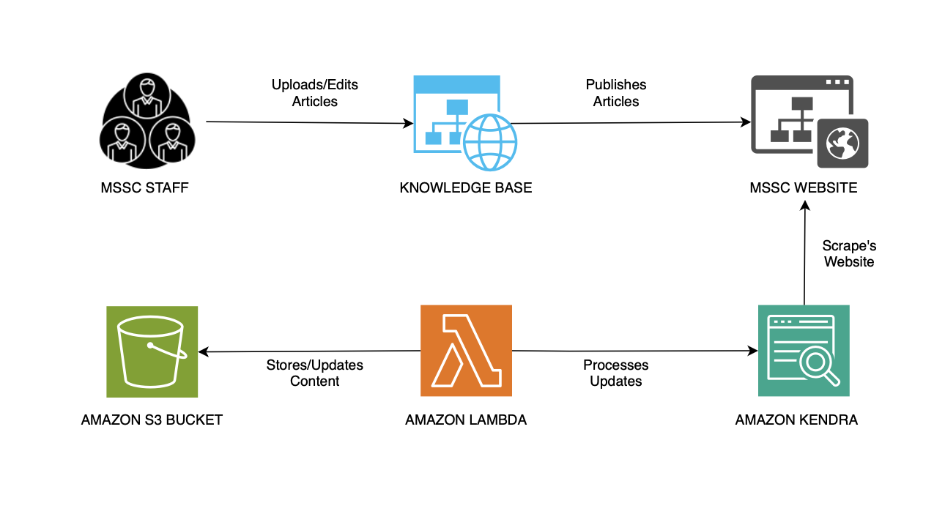The dataset will be processed and integrated into AWS services, with a primary focus on Amazon Kendra, which facilitates intelligent search and retrieval capabilities. Amazon Kendra will allow the chatbot to deliver real-time, contextually relevant responses by searching the MSSC Knowledge Base for the most appropriate content. Throughout the 6-month pilot phase, the dataset will be regularly updated to ensure that the chatbot remains accurate and reliable as an information source. Additionally, the chatbot might integrate real-time feeds from other university systems to provide dynamic updates on critical services like class schedules, deadlines, and Figure 5: MSSC Chatbot Content Flow and Integration

The data flow begins with the MSSC staff, who regularly upload and edit articles in the knowledge base. These articles cover various topics, and the staff ensures that they are up-to-date and aligned with the university’s policies. Once the content is uploaded to the MSSC Knowledge Base, it is published on the MSSC website, making the information accessible to students through a web interface.

To ensure efficient data retrieval, Amazon Kendra scrapes and indexes the content from the MSSC website. This allows the chatbot to perform intelligent searches and retrieve the most relevant answers to student queries from the indexed knowledge base. Amazon Lambda acts as the processing engine that handles updates to the knowledge base, processes requests, and manages the flow of information between AWS services. Once updates are processed, Amazon Lambda stores the data in Amazon S3, ensuring secure and scalable storage for the dataset.

This integration between the MSSC Knowledge Base and AWS services like Amazon Kendra, Amazon Lambda, and Amazon S3 ensures that the Generative AI chatbot can provide accurate, real-time information to students. By maintaining a continuously evolving dataset, the chatbot will always have access to the latest information, allowing for more efficient support and enhanced student experience.

* 1. **Field Descriptions**

The data extracted from the MSSC knowledge base is structured with various fields, each playing a crucial role in helping the chatbot provide accurate and context-relevant information to users. These fields include:

1. **Title** (Type: string) – The title of the article provides a clear description of its content. It helps categorize the article within the knowledge base for easy retrieval during searches.
2. **Publication Date** (Type: datetime) – The date on which the article was published or last updated. This field ensures the chatbot provides up-to-date and accurate information to users.
3. **Question** (Type: string) – The specific question addressed by the article. This serves as the prompt for the answer provided, helping users quickly identify if the article addresses their query.
4. **Answer/Content** (Type: string) – The main body of the article, which provides detailed information or instructions in response to the question. This is the key content used by the chatbot for responding to user queries.
5. **Tags/Keywords** (Type: string) – Keywords associated with the article that help improve the accuracy of search results. Tags can be related to the subject matter or commonly asked questions.
6. **Related Articles** (Type: array of strings) – A list of articles related to the current one, offering additional resources or information on similar topics.
7. **Attachments/Links** (Type: array of strings) – Hyperlinks or buttons within the article that provide additional resources or direct the user to more detailed information.
   1. **Data Context**
      1. **Data Source**

The primary data source for this project is the Mason Student Services Center (MSSC) knowledge base, which is housed on the Mason Self-Service Knowledge Base portal. This knowledge base is a centralized repository of information related to university services, policies, procedures, and student resources. It includes a wide range of content, such as articles, FAQs, guides, and instructional documents, all of which are designed to support students in navigating university life. The MSSC knowledge base is regularly updated by MSSC staff to reflect the most current information, ensuring that students have access to up-to-date guidance on various services, such as registration, financial aid, housing, and academic advising. This real-time update process ensures that the AI RAG chatbot can provide students with accurate and relevant responses based on the latest available data.

* + 1. **Data Collection**

The data collection process is a key component of this project, and it begins with the use of a web crawler integrated with Amazon Kendra, a powerful enterprise search service. The web crawler is responsible for automatically gathering content from the MSSC knowledge base by scraping articles, FAQs, and other informational documents. This content is then indexed by Amazon Kendra, making it easy for the AI RAG chatbot to retrieve the most relevant information during user interactions. The web crawler ensures that all new and updated content from the MSSC knowledge base is promptly included in the search index, allowing the chatbot to provide the most current answers to students’ queries. In addition to the text content, metadata is collected and added to the articles, such as publication dates, tags, categories, and links to related articles. This metadata enhances the chatbot’s ability to retrieve contextually accurate information and improve the overall user experience.

* + 1. **Data Description**

The MSSC knowledge base data consists primarily of articles that address frequently asked questions and provide detailed instructions and guidance on a variety of student services. Each article is typically structured with a clear title, a publication date, a specific question or issue, and a comprehensive answer or solution. The articles are designed to be easily understood, providing students with direct answers to their inquiries. In addition to the core article content, many entries include supplementary resources, such as links to related articles, downloadable files or attachments, and references to other sections of the knowledge base. These supplementary resources help provide a richer context for the user, ensuring that they can access all the relevant information they may need. The data is organized in a way that allows the chatbot to quickly access and present answers that are not only accurate but also contextually relevant to the student’s query. By maintaining a structured and continuously updated dataset, the MSSC ensures that the AI RAG chatbot remains a reliable and efficient tool for providing real-time support to students, helping them navigate university services and make informed decisions.

* 1. **Data Conditioning**

In the AI chatbot for GMU MSSC’s website, data conditioning is handled primarily by Amazon Kendra, which automatically crawls the website to gather and index content. This indexed data includes articles, FAQs, and other resources published on the MSSC knowledge base. Kendra organizes the data based on the existing website structure, such as metadata like publication dates, tags, and categories, which ensures that the content is searchable and accessible. The chatbot can then use this indexed data to provide accurate, contextually relevant responses to user queries. Since Kendra performs the indexing directly from the website, there is no need for additional data cleaning or normalization steps. This streamlined process ensures that the chatbot has access to up-to-date and well-structured information, enabling real-time, efficient support for users.

We indexed the knowledge base in Amazon Kendra using a full sync mode for the MSSC knowledge base. This setup ensures that all relevant content is continuously synced and indexed for efficient retrieval. The sync was configured to encompass everything within the domain, with a crawl depth set to 3 to capture nested pages. Other key parameters include a maximum file size of 50 MB, a limit of 100 links or pages per crawl, and throttling set to 300 URLs per hostname per minute. Files linked to the web pages were included in the crawl to ensure comprehensive coverage of the data.

During the process, a total of 1,447 items were scanned, with 1 item failing to be indexed. Logs and a detailed report are available through CloudWatch for further analysis and debugging of the failed items. This configuration allows the chatbot to have access to the most up-to-date information, ensuring accurate and timely responses for students seeking assistance from the MSSC.

URL Crawl Inclusion patterns: <https://mason.my.site.com/>.*, https://.*.gmu.edu/.*

The logic was added to crawl data only from the above URLs, ensuring focused and relevant data indexing as per the business requirements

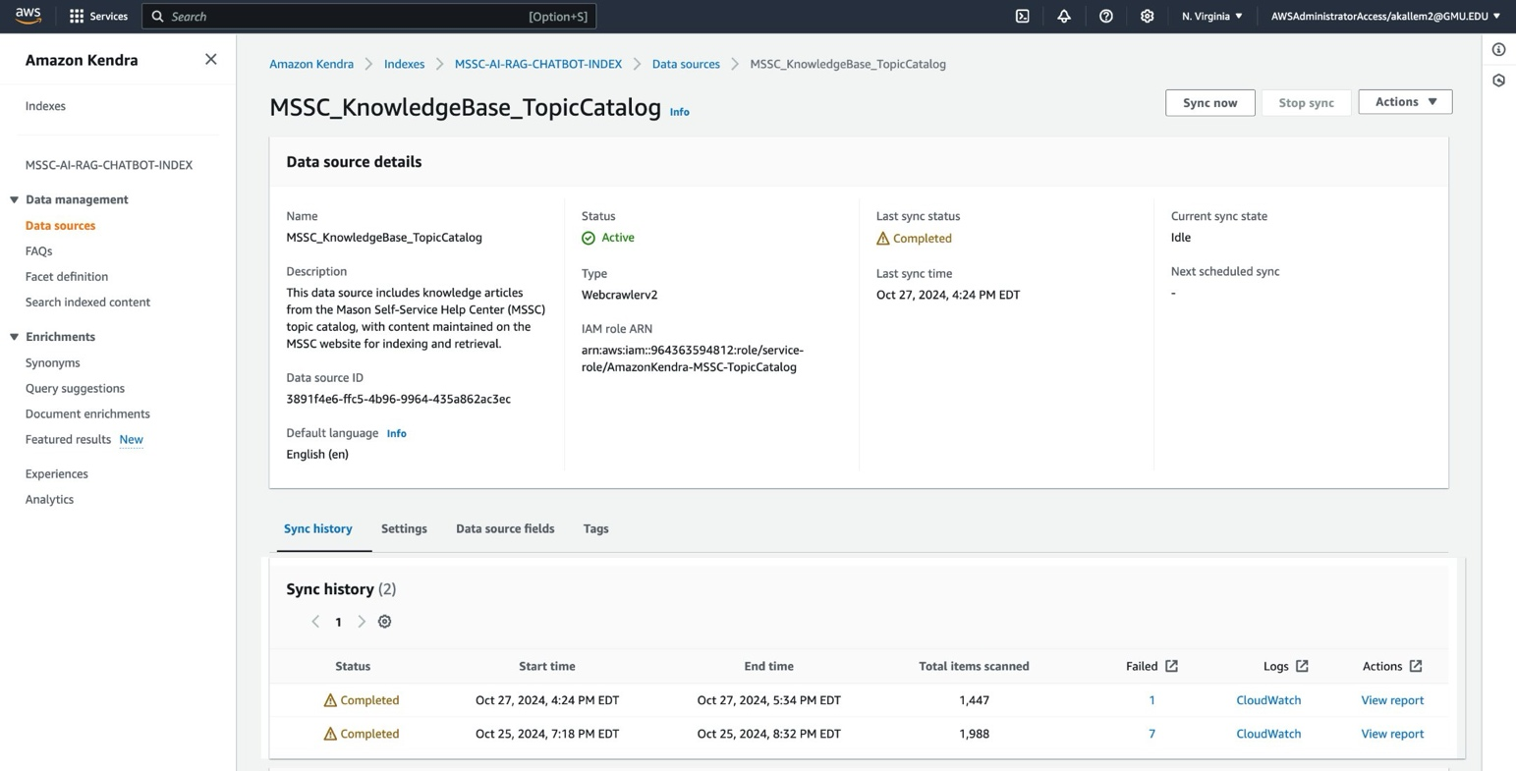

* + 1. **IAM Roles and Security Configurations**

To maintain security and control over access to various AWS services, the project uses well-defined IAM roles. These roles ensure that only the necessary components of the system have permission to perform specific tasks, like indexing the data or accessing sensitive information. Each part of the system has its own IAM role, following a strict least privileged policy, meaning that every service only has the minimum access it needs to function properly, which enhances security.

For example, Amazon Kendra, which handles crawling and indexing the MSSC knowledge base, uses a dedicated IAM role to do its job. The role with ARN arn: aws:iam::964363594812: role/service-role/AmazonKendra-us-east-1-RAG-kendra-index was created specifically for Kendra to build its index. This role gives Kendra permission to read and crawl the MSSC website content, ensuring that it gathers all the information the chatbot needs to answer student queries. We also use a separate IAM role to connect Kendra to its data source. The role with ARN arn:aws:iam::964363594812: role/service-role/Amazon Kendra-MSSC-Topic Catalog allows Kendra to pull the necessary data from the MSSC Topic Catalog, making sure the chatbot has access to up-to-date and relevant content.

By assigning specific IAM roles to each service, we make sure access to AWS resources is secure and well-controlled. This not only protects the system but also makes it easy to track and audit access, ensuring that everything complies with university policies and industry’s best practices.

* + 1. **Cloudformation Templates and Infrastructure**

AWS CloudFormation is a service provided by Amazon Web Services (AWS) that enables users to model and manage infrastructure resources in an automated and secure manner. Using CloudFormation, developers can define and provision AWS infrastructure resources using a JSON- or YAML-formatted infrastructure as code template. The service was released on February 25, 2011.

CloudFormation provides a way for users to model an entire AWS infrastructure in a text file, allowing for the infrastructure to be version-controlled, shared, and reused. By using templates, users can create, update, and delete a collection of resources together as a single unit, known as a stack.

For our project, we utilized AWS CloudFormation to streamline our deployment and ensure consistent infrastructure. We created three specific stacks to meet our project needs:

1. MSSC-CHATBOT: This is the main stack for the chatbot, encompassing all the core components required for its operation.
2. QNABOTPLUGIN-BEDROCK-EMBEDDINGS-AND-LLM: This stack is used for embedding and language model functionalities, ensuring that our chatbot can process and understand natural language effectively.
3. lex-web-ui-mssc-rag-ai-chatbot: This stack is dedicated to the user interface of the chatbot, providing a seamless interaction experience for users.

**3.4.2.1 QNABOTPLUGIN-BEDROCK-EMBEDDINGS-AND-LLM**

The QNABot Plugin Stack was developed as the foundational engine powering the chatbot. This stack integrates the Anthropic Claude 3.5 Sonnet model within AWS Bedrock, effectively providing the chatbot with its intelligent "brain." The Claude 3.5 model offers significant improvements over the previous Claude 3 model used in the spring, including enhanced reasoning capabilities, more fluid conversation flow, and a superior ability to manage complex queries. Additionally, AWS Lambda was incorporated into the stack to support advanced date logic, ensuring that the chatbot is capable of accurately handling time-sensitive queries. This stack plays a critical role in embedding and enabling the language model functionalities required for the chatbot’s performance.

**Parameters:**

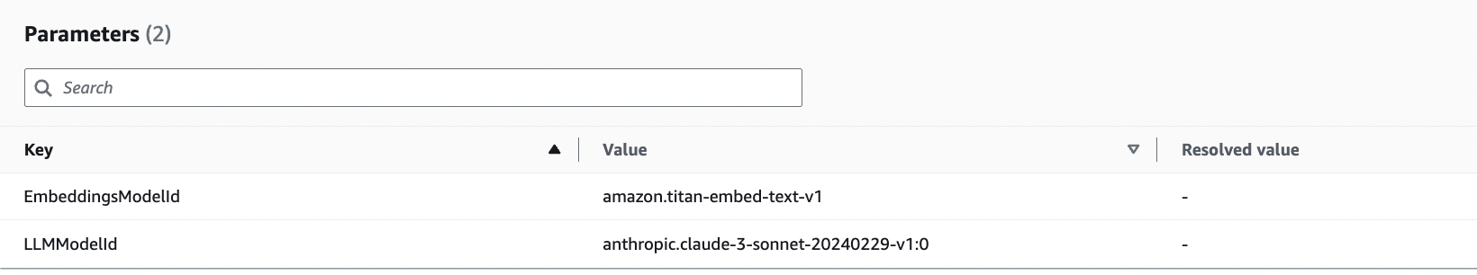

**Outputs:** EmbeddingsLambdaArn and LLMLambdaArn, are used in the creation of the MSSC-RAG-CHATBOT stack.

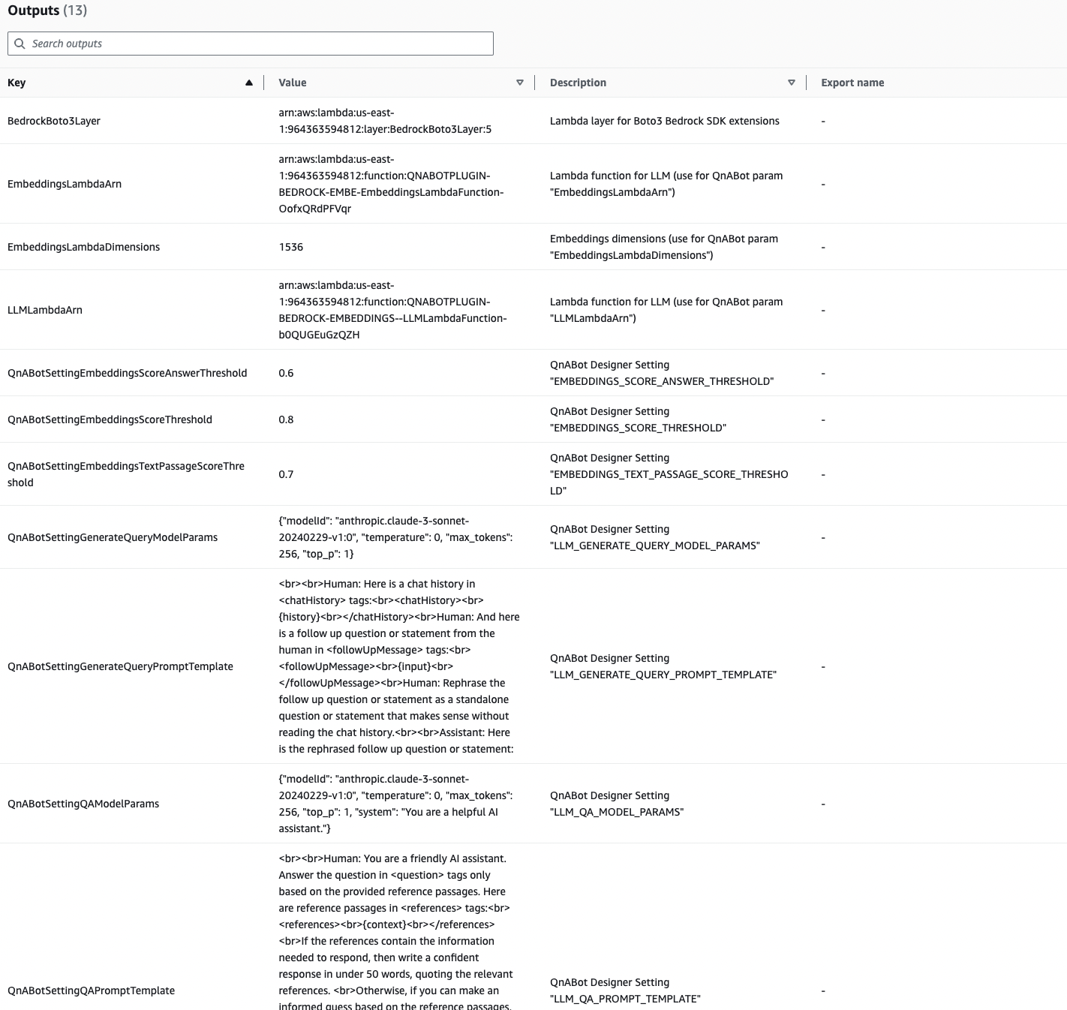

**Date Logic:** To handle time-sensitive queries, AWS Lambda was incorporated into the stack to support advanced date logic. The parameters for this date logic, which will be used in prompt engineering, are outlined in the screenshot of the **QNABOTPLUGIN-BEDROCK-EMBEDDINGS--LLMLambdaFunction-b0QUGEuGzQZH**. This ensures that the chatbot is capable of accurately processing and responding to time-related inquiries.

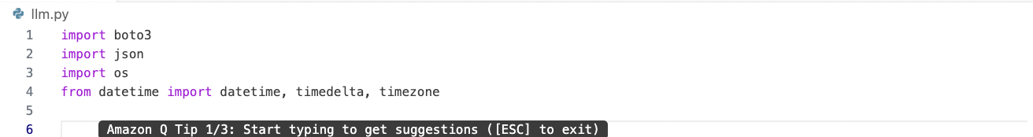

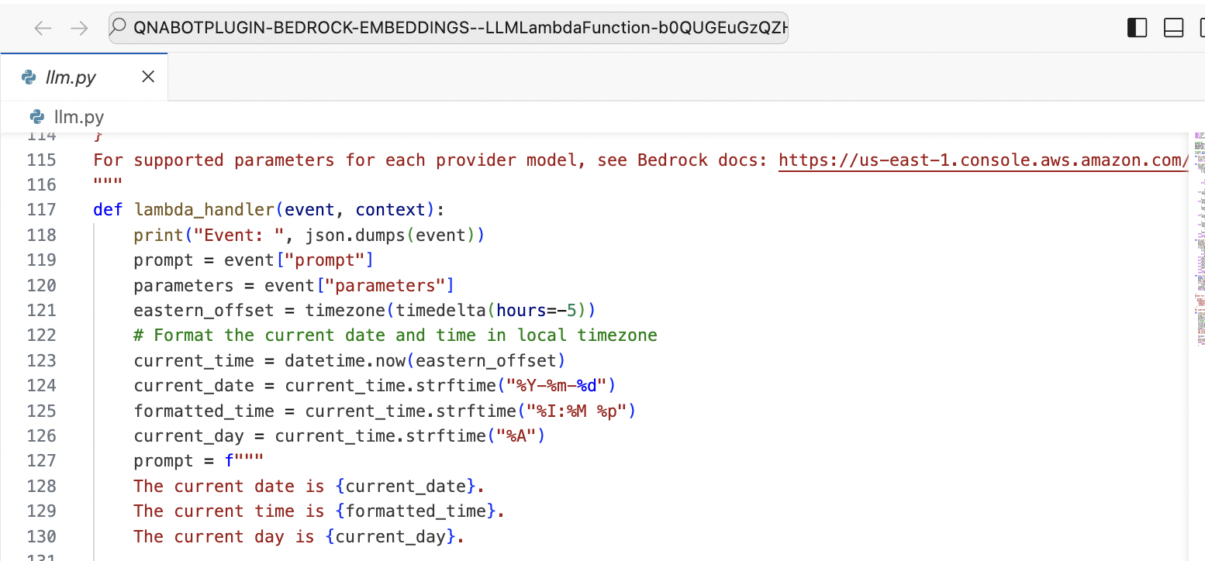

**3.4.2.2 MSSC-CHATBOT**

The final component of our setup was the creation of the **MSSC Chatbot Stack**, which serves as the backbone of the entire chatbot system. This stack consolidates all core components, integrating the previously developed **QNABot Plugin Stack** (which includes AWS Bedrock, Lambda, and the Kendra index) with additional services such as **Amazon Lex**, **DynamoDB**, **S3**, and **Amazon Cognito**.

Key OUPUT elements of the MSSC Chatbot Stack include:

* **ClientURL:** This URL provides access to the client interface, where users can interact with the chatbot in a live environment.
* **ContentDesignerURL:** This URL gives access to the content designer interface, enabling the creation, management, and updating of the chatbot's content.
* **LexV2BotAliasId** and **LexV2BotId:** These identifiers are critical in the configuration of the **lex-web-ui-mssc-rag-ai-chatbot** stack, ensuring the correct setup and deployment of the chatbot within **AWS Lex V2**.

**Parameters:**

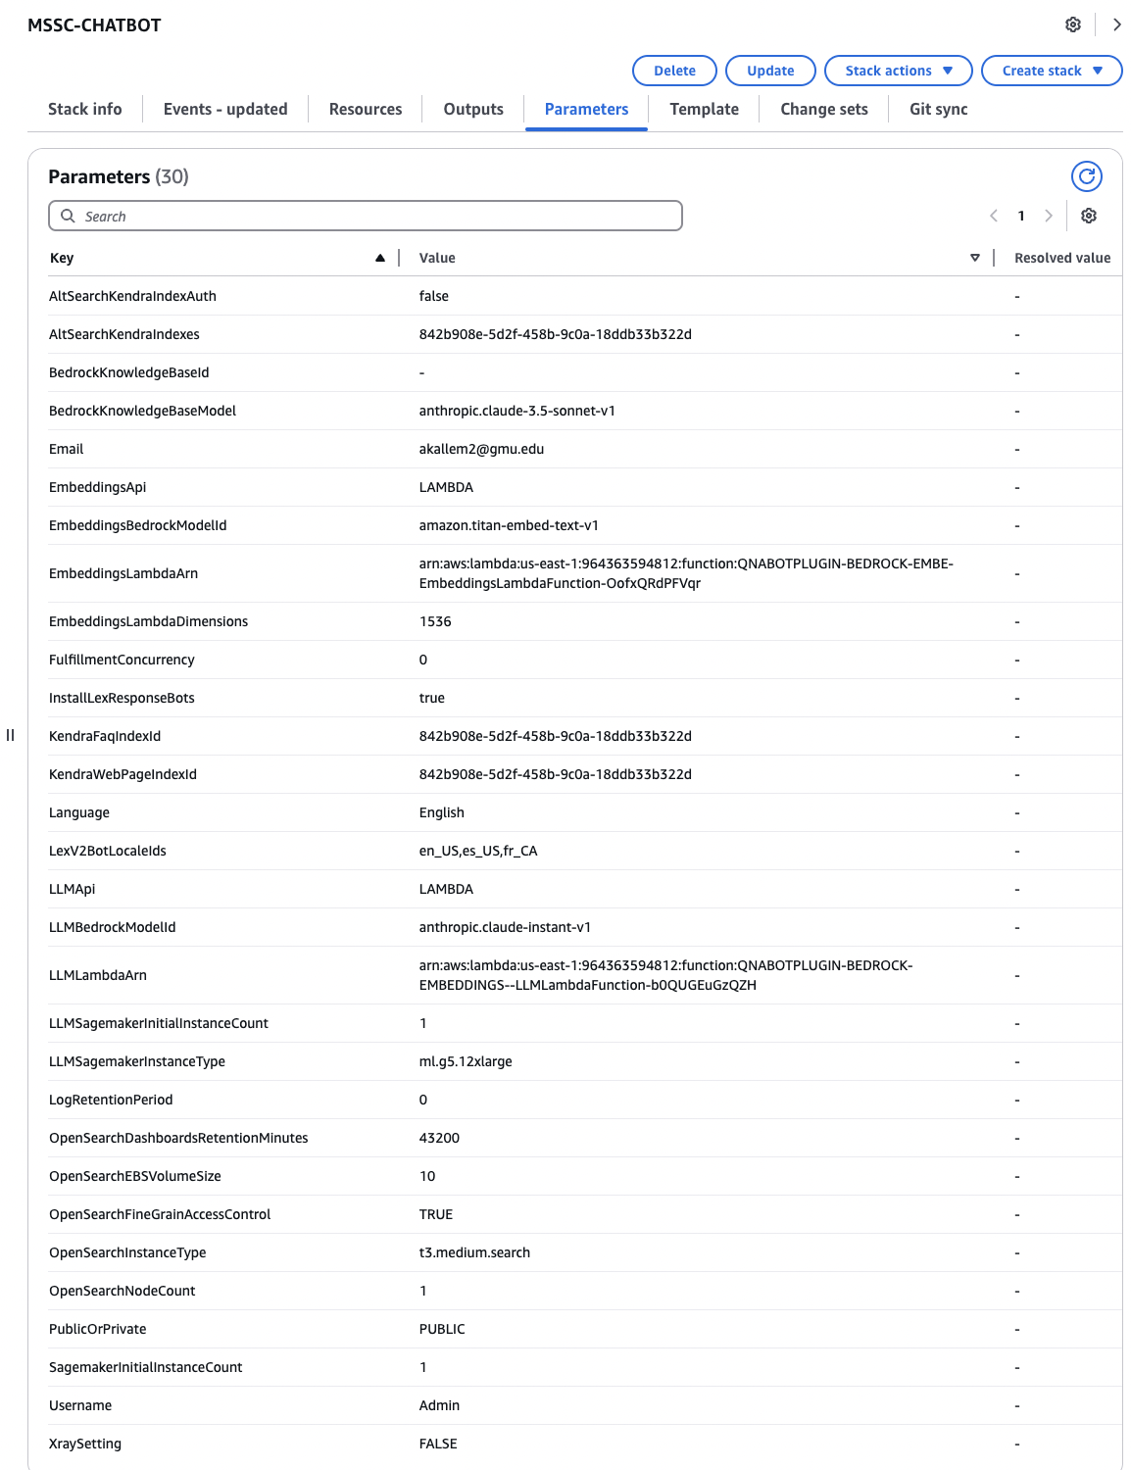

**Outputs:**

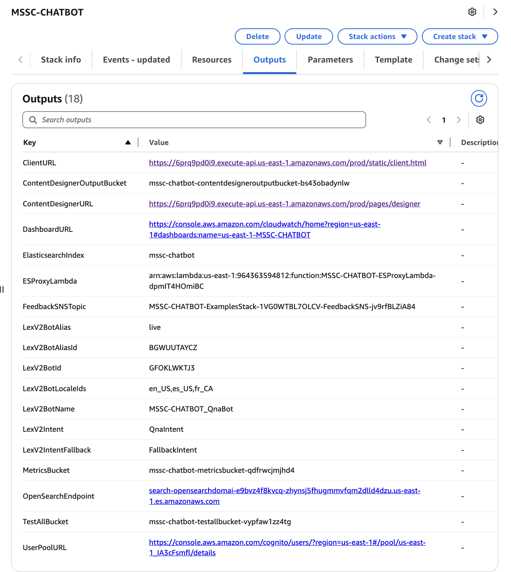

**Client Landing Page:**

The client landing page for our chatbot is designed to provide an interactive and personalized experience for both Mason and non-Mason users. This page serves as the primary interface through which users can interact with the chatbot, receive real-time answers, and leverage the power of advanced AI technology. Access to this interface is facilitated through the **clientURL**: <https://6prq9pd0i9.execute-api.us-east-1.amazonaws.com/prod/static/client.html>.

To make the experience even more tailored, we've customized the landing page to meet the unique needs of each user.

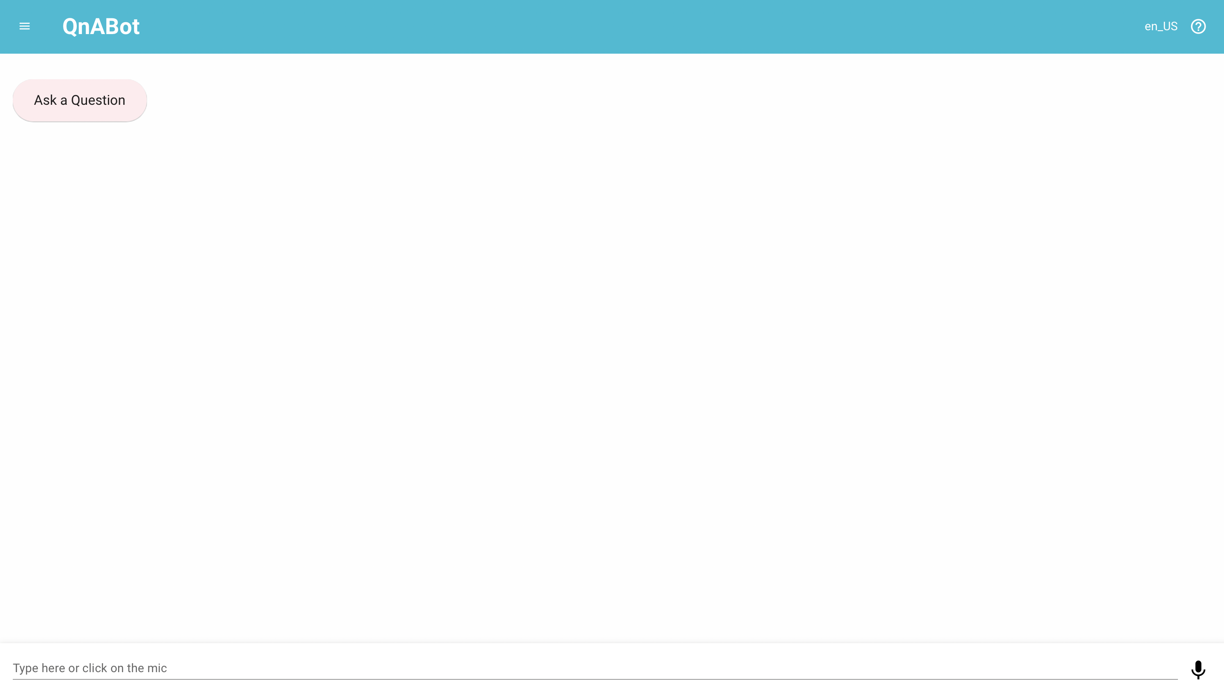

**Content Designer**

The **Content Designer** is a key component of the MSSC Chatbot Stack, offering an intuitive interface that enables the creation, management, and updating of the chatbot’s content. This interface empowers authorized users to define, refine, and customize the chatbot’s responses, ensuring that it provides accurate, relevant, and contextually appropriate information to users.

Access to this interface is facilitated through the **ContentDesignerURL(**<https://6prq9pd0i9.execute-api.us-east-1.amazonaws.com/prod/pages/designer>), which streamlines the content management process, making it efficient and user-friendly. The settings available within the Content Designer allow for ongoing adjustments and improvements, ensuring continuous fine-tuning of the chatbot’s conversational abilities. These settings play a pivotal role in enhancing the chatbot’s performance, enabling it to adapt to changing user needs and provide an increasingly seamless user experience over time.

**Settings:**









**Handling Thumbs Up and Thumbs Down Logic:**

The QnaUtility is imported to manage user feedback, including thumbs up and thumbs down, which plays a vital role in improving chatbot performance. It provides the following key functionalities:

* **Feedback Mechanism: Handles** thumbs-up/thumbs-down responses, allowing users to provide feedback that improves the chatbot’s answers over time.
* **Response Quality Tracking:** Analyzes feedback to assess response quality and identify areas for improvement.
* **User Interaction Metrics:** Tracks patterns in feedback to better understand user experience and further enhance the system.

By integrating QnaUtility, the chatbot continuously evolves based on real-time feedback, ensuring higher user satisfaction and improved responses.

**Steps to Load QnaUtility in Content Designer**

1. **Go to the Import Section**: In the **Content Designer**, navigate to the **Import** section to manage external utilities and libraries.
2. **Check QnaUtility in Examples/Extensions**: In the **Examples/Extensions** section, locate the **QnaUtility** function, which provides essential tools like feedback management to enhance the chatbot's interactions.
3. **Click to Load QnaUtility**: Click the **Load** button next to **QnaUtility** to import and activate it. This enables features such as thumbs up/thumbs down feedback management in the chatbot.

**Feedback Management in Content Designer:**

Once **QnaUtility** is loaded, you can configure the feedback mechanisms to manage user responses such as **Thumbs Up** and **Thumbs Down**. These feedback options allow users to rate the chatbot's performance, and the system uses this data to refine future interactions.

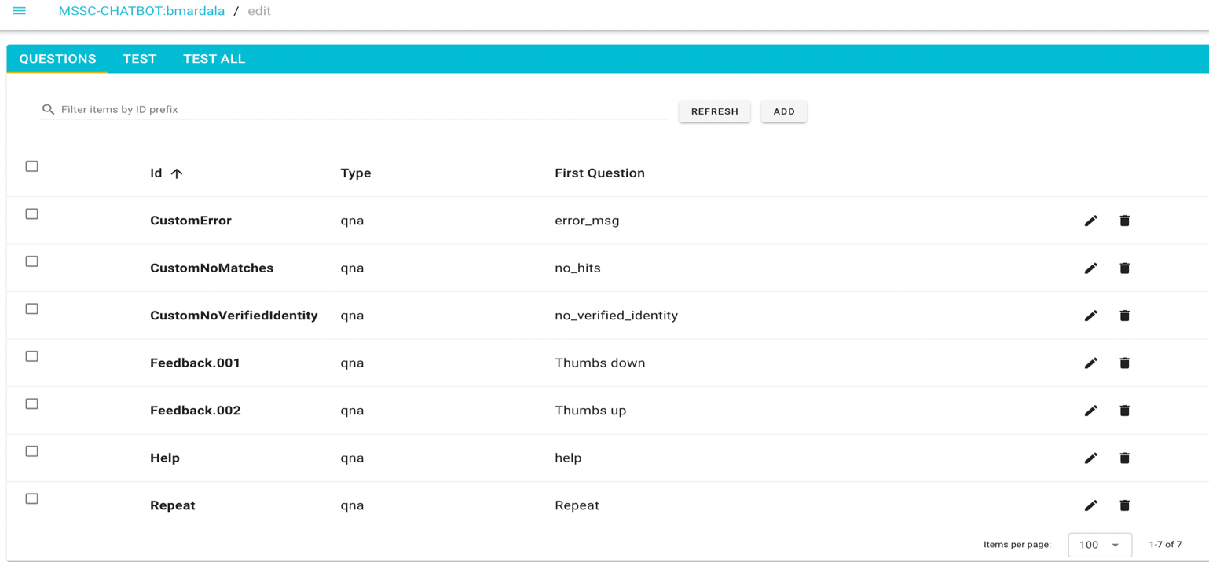

**Thumbs Up:**



**Thumbs Down:**



**3.4.2.3 lex-web-ui-mssc-rag-ai-chatbot** :

The final component of our setup, focused on customizing the user interface to provide a cohesive and branded experience. This stack allows for the modification of the landing page layout to align with **George Mason University’s** branding, ensuring a tailored user experience that reflects the institution's identity.

To ensure consistency with GMU’s branding, several customizations were implemented:

1. The **GMU logo** was incorporated into the chatbot interface for brand recognition.
2. The signature **green color (#005239)**, which is a hallmark of GMU’s branding, was applied to the interface to maintain a consistent visual identity.
3. The toolbar was renamed to **"MSSC Chatbot"** for clear and easy identification by users.
4. The bot's avatar was updated to **GMU’s monogram**, reinforcing the university's branding.
5. The chatbot greeting was customized to say, **“Looking for something? Let me assist you!”** offering a friendly and inviting message to users.
6. **Markdown support** was enabled, allowing the chatbot to present clearer responses using **bold text** and **bullet points**, improving the readability of its answers.

**Parameters:**

|  |  |  |
| --- | --- | --- |
| **Key** | **Value** | **Resolved value** |
| AllowedSignUpEmailDomain | - | - |
| AllowStreamingResponses | false | - |
| AmazonQAppId | - | - |
| BackButton | false | - |
| BootstrapBucket | aws-bigdata-blog | - |
| BootstrapPrefix | artifacts/aws-lex-web-ui/artifacts | - |
| BotAlias | $LATEST | - |
| BotAvatarImgUrl | <https://gmu.bynder.com/m/23ae598a3159a37/original/GM-monogramRGB-png.png> | - |
| BotChatBubble | - | - |
| BotName | - | - |
| ChatBackgroundColor | - | - |
| CleanupBuckets | true | - |
| CodeBuildName | lex-web-ui-mssc-rag-ai-chatbot | - |
| CognitoIdentityPoolId | - | - |
| CognitoIdentityPoolName | Lex Web UI | - |
| ConnectAgentJoinedMessage | {Agent} has joined. | - |
| ConnectAgentLeftMessage | {Agent} has left. | - |
| ConnectAttachChatTranscript | false | - |
| ConnectChatEndedMessage | Chat ended. | - |
| ConnectContactFlowId | - | - |
| ConnectEndLiveChatIcon | call_end | - |
| ConnectEndLiveChatLabel | End Live Chat | - |
| ConnectInstanceId | - | - |
| ConnectLiveChatTerms | live chat | - |
| ConnectPromptForNameMessage | Before starting a live chat, please tell me your name? | - |
| ConnectStartLiveChatIcon | people_alt | - |
| ConnectStartLiveChatLabel | Start Live Chat | - |
| ConnectTranscriptMessageDelayInMsec | 150 | - |
| ConnectWaitForAgentMessage | Thanks for waiting. An agent will be with you when available. | - |
| ConnectWaitForAgentMessageIntervalInSeconds | 60 | - |
| CustomerChatBubble | - | - |
| EnableCognitoLogin | false | - |
| EnableMarkdownSupport | true | - |
| ForceCognitoLogin | false | - |
| HideButtonMessageBubble | false | - |
| IDCApplicationARN | - | - |
| LexV2BotAliasId | LFJX1SM67K | - |
| LexV2BotId | XEXYJHPVQX | - |
| LexV2BotLocaleId | en_US | - |
| MessageFont | - | - |
| MessageMenu | false | - |
| MessageTextColor | - | - |
| MinimizedButtonColor | - | - |
| MinimizedButtonContent | - | - |
| ReInitSessionAttributesOnRestart | false | - |
| retryCountPostTextTimeout | 1 | - |
| retryOnLexPostTextTimeout | false | - |
| SaveHistory | false | - |
| ShouldDeleteBot | true | - |
| ShouldEnableLiveChat | false | - |
| ShouldEnableUpload | false | - |
| ShouldLoadIframeMinimized | false | - |
| ShowResponseCardTitle | false | - |
| TitleLogoImgUrl | <https://mssc-ai-rag-chatbot-client-resources.s3.us-east-1.amazonaws.com/log.png> | - |
| ToolbarColor | #005239 | - |
| UploadBucket | - | - |
| WebAppAcmCertificateArn | - | - |
| WebAppConfBotInitialSpeech | Looking for something? Let me assist you! | - |
| WebAppConfBotInitialText | Looking for something? Let me assist you! | - |
| WebAppConfBotInitialUtterance | - | - |
| WebAppConfCname | - | - |
| WebAppConfHelp | Help | - |
| WebAppConfNegativeFeedback | Thumbs down | - |
| WebAppConfPositiveFeedback | Thumbs up | - |
| WebAppConfToolbarTitle | MSSC CHATBOT | - |
| WebAppParentOrigin | - | - |
| WebAppPath | /parent.html | - |
| WebAppWafAclArn | - |  |

**Outputs:**

The **WebAppUrl** is the final landing page for your chatbot, featuring the updated layout. This page will reflect the latest changes and customizations, ensuring it aligns with GMU branding and provides a seamless user experience.

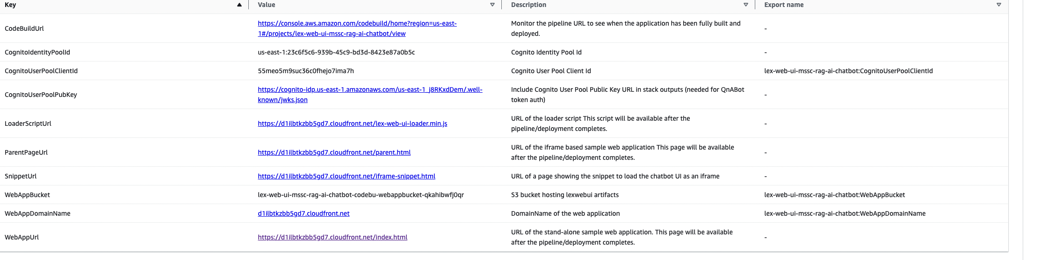

**Landing Page:**

To align with George Mason University’s branding, we customized the chatbot interface with the GMU logo, signature green color (#005239), and renamed the toolbar to "MSSC Chatbot". Usability was enhanced with GMU’s monogram as the bot’s avatar, a welcoming greeting, and Markdown support for clearer, formatted responses.

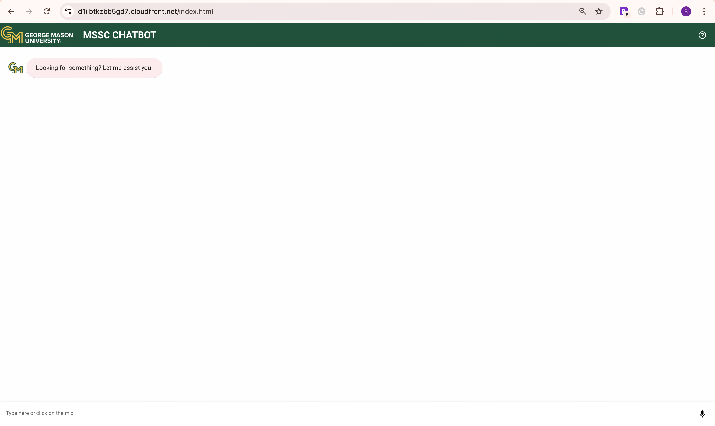

* 1. **Data Quality Assessment**

Assessing the quality of the data from the **MSSC knowledge base** is critical to ensuring the effectiveness of the chatbot’s responses. Below is an evaluation of the dataset using key data quality attributes:

1. **Completeness**: Completeness refers to the presence of all necessary fields in the dataset. For the chatbot to function properly, all articles should include important metadata such as titles, publication dates, content, and tags. Incomplete records can lead to inaccurate responses or difficulty retrieving the correct information.
2. **Uniqueness**: This attribute ensures that each record in the knowledge base is distinct and not duplicated. Each article or FAQ entry should have a unique identifier or URL to prevent redundancy and confusion. Duplicated content can decrease the efficiency of the chatbot by serving repetitive or conflicting information to users.
3. **Accuracy**: Accuracy is essential in providing users with correct information, especially when it comes to time-sensitive matters like deadlines, admissions policies, and financial aid details. The data must be reviewed regularly by MSSC staff to ensure that any changes in policies or procedures are accurately reflected in the knowledge base.
4. **Atomicity**: The dataset should be broken down into its simplest components. Each field, such as the title, content, publication date, and tags, must be atomic, meaning they contain a single, indivisible piece of information. This ensures that each element is independently searchable and retrievable by Amazon Kendra.
5. **Conformity**: Conformity refers to the dataset adhering to a standard format. All entries must follow a consistent structure for fields such as dates, tags, and URLs. For example, publication dates should follow a uniform format, ensuring that all data is processed and indexed correctly.
6. **Overall Quality**: The overall quality of the dataset is dependent on regular updates, consistent formatting, and completeness of the records. To maintain high-quality data, the MSSC staff must regularly review and update articles to ensure relevance, accuracy, and comprehensiveness, thus enabling the chatbot to provide timely and accurate responses.
   1. **Other Data Sources**

In addition to the MSSC knowledge base, the chatbot will pull information from other data sources to ensure that it can provide real-time, dynamic updates. These sources may include:

1. **University Calendars**: Data on academic and administrative deadlines (e.g., registration deadlines, drop/add periods, exam schedules).
2. **API Feeds**: APIs provide real-time information on topics such as tuition fees, class schedules, and student account balances.
   1. **Storage Medium**

For this project, Amazon S3 (Simple Storage Service) has been chosen as the storage medium for the dataset. Amazon S3 is ideal because it offers secure, scalable, and durable storage, allowing for easy storage and retrieval of the MSSC knowledge base data, which includes articles, FAQs, and metadata. The flexibility of S3 allows it to store different types of data, and its integration with other AWS services, like Amazon Kendra and AWS Lambda, makes it an efficient choice for data retrieval during chatbot interactions. Additionally, the service guarantees high availability by storing data across multiple locations, making it reliable for 24/7 access by the chatbot.

* 1. **Storage Security**

The storage security for this project is a critical component to ensure the protection of the MSSC knowledge base dataset. Amazon S3 provides multiple layers of security, starting with encryption at both rest and in transit. Data stored in S3 is encrypted using server-side encryption (SSE), and data is encrypted in transit using HTTPS to prevent unauthorized access during data transfer.

Access to the stored data is managed through a robust set of policies rather than Access Control Lists (ACLs). With ACLs disabled, access to the data is controlled through a combination of AWS Identity and Access Management (IAM)policies, S3 bucket policies, Virtual Private Cloud (VPC) policies, and AWS Organizations Service Control Policies. These policies define who can access, modify, or manage the data. In this project, the security policies are managed by the GMU CEC Information Technology (IT) help desk, which has set up the AWS account on behalf of the project team and controls access through specific user roles and permissions.

* 1. **Storage Costs**

The storage costs for this project are primarily determined using Amazon S3, which charges based on the amount of data stored, the number of requests made, and data transferred out of S3. For example, storing 100 GB of data in S3 would cost approximately $2.30 per month, based on the S3 Standard pricing at $0.023 per GB for the first 50 TB of data. In addition to storage, Amazon S3 charges for requests, with 1,000,000 GET requests costing around $0.40. If 100 GB of data is transferred out of S3, this would incur an additional cost of about $9.00, given the transfer rate of $0.09 per GB beyond the first GB. Therefore, the total estimated cost for storing 100 GB of data, making 1,000,000 requests, and transferring 100 GB of data would be approximately $3.27 per month. These costs will be scaled based on the amount of data stored, the frequency of access, and the volume of data transferred, and can be optimized by monitoring usage patterns throughout the project.

# Implementation

## Solution Approach

### **Systems Architecture**

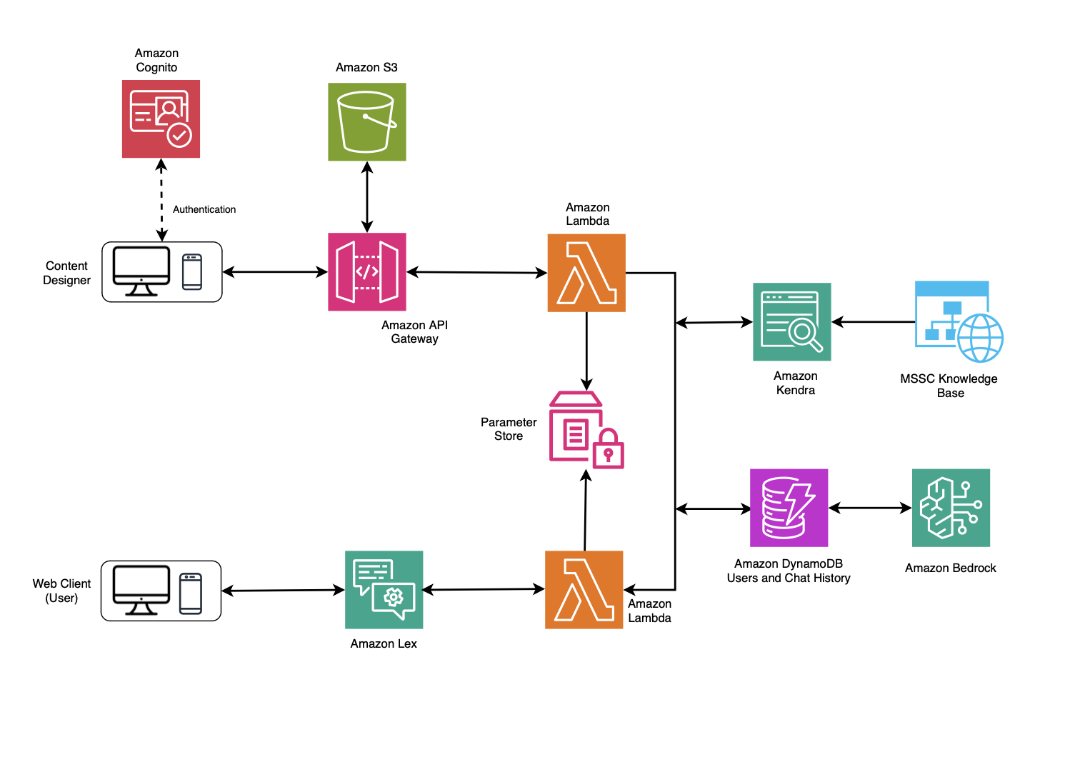

Figure 5: New Architecture for 6-Month Pilot Setup

The proposed system architecture for the chatbot, designed for a 6-month pilot setup, facilitates efficient user interactions through a website. It integrates various AWS services to ensure scalability, reliability, and security.

At the core of the architecture is Amazon Lex, which processes user queries submitted through the website and triggers Lambda functions for further handling. The system utilizes Amazon Kendra to retrieve relevant documents from the MSSC website, enhancing the chatbot's ability to provide accurate information.

The architecture incorporates Amazon Bedrock to invoke appropriate Large Language Models (LLMs), generating natural language responses based on user queries and retrieved documents. Responses, along with user queries, are stored in DynamoDB, allowing for context-aware interactions by maintaining a history of conversations.

Furthermore, the Content Designer interface, accessible to authorized developers via Amazon Cognito, enables the configuration of various system aspects, including managing the Kendra index. This comprehensive architecture supports a seamless user experience while ensuring data security and efficient resource management.

### **Systems Security**

The proposed chatbot system incorporates robust security measures to align with established legal and ethical frameworks, ensuring transparent and accountable operations. The system also adheres to best practices for data management, user privacy, and security protocols, guaranteeing that interactions with the chatbot are secure and that user data is handled responsibly. By implementing these measures, the system demonstrates its commitment to protecting sensitive information and maintaining user trust while leveraging AI to enhance the overall user experience. To further bolster data protection, the architecture utilizes Amazon Cognito for secure user authentication and authorization, restricting access to the Content Designer interface to authorized developers only. This interface facilitates the configuration of various system components, including the management of the Kendra index. Through these security measures, the architecture ensures a seamless user experience while safeguarding sensitive data and adhering to relevant guidelines.

### **Systems Data Flows**

When an end-user visits the website and interacts with the chatbot, the process begins with Amazon Lex, which triggers a Lambda function. The user's query is sent to the RAG (Retrieval-Augmented Generation) component, which utilizes its search capabilities to retrieve relevant documents from the MSSC website via the Amazon Kendra index. Once the documents are retrieved, they, along with the original user query, are processed through the Systems Manager Parameter Store, where parameters like prompt engineering are applied.

The user’s query, the retrieved documents, and the prompt engineering instructions are forwarded to Amazon Bedrock, which calls the appropriate Large Language Model (LLM). The LLM generates a natural language response, which is recorded in DynamoDB along with the user’s queries and responses. DynamoDB enables the chatbot to store these queries and answers, allowing it to track past conversations and provide more personalized interactions.

Additionally, the Content Designer interface empowers authorized developers, verified through Amazon Cognito, to configure various aspects of the chatbot solution. This includes setting up Amazon Kendra to crawl the MSSC website and creating the necessary Kendra index, all without the need for a custom web client or complex authentication mechanism.

### **Algorithms and Analysis**

The development of the MSSC Generative AI Chatbot harnessed an advanced array of algorithms, integrating state-of-the-art techniques to ensure the system could interpret and respond to user queries with exceptional precision and relevance. Central to this innovative system is the Retrieval-Augmented Generation (RAG) Framework, a cutting-edge architecture that marries retrieval and generation capabilities for superior interaction quality.

The process begins the moment a user submits a query. Amazon Kendra, renowned for its robust information retrieval capabilities, acts as the system's backbone for document discovery. Unlike traditional keyword-based searches, Kendra employs semantic search algorithms powered by sophisticated machine learning models. These algorithms delve deeper than mere keyword matching, decoding the nuanced meanings and context behind user inquiries. This enables Kendra to not only retrieve but also rank documents based on their alignment with the user’s intent, ensuring that the system consistently delivers highly relevant information.

Once Kendra identifies and retrieves these contextually pertinent documents, they are seamlessly passed to Amazon Bedrock’s advanced Large Language Model (LLM). At this stage, the LLM performs a crucial role—synthesizing the retrieved data into a coherent, contextually rich, and highly accurate response tailored to the user's specific question. This synergistic interplay between retrieval and generation ensures that the chatbot excels in delivering precise, meaningful, and actionable answers.

Moreover, the semantic search capabilities of Amazon Kendra stand out as a transformative feature, elevating the chatbot's performance to new heights. By understanding user queries at a conceptual level, Kendra can identify connections and patterns within the MSSC knowledge base that traditional search systems would miss. This allows the chatbot to handle complex, multi-faceted queries with ease, providing responses that are not only accurate but also insightful and comprehensive.

In essence, the MSSC Generative AI Chatbot exemplifies the potential of next-generation AI systems, where dynamic retrieval mechanisms and contextual language models work in perfect harmony. By leveraging the unparalleled capabilities of RAG, semantic search, and cutting-edge LLM technology, the chatbot delivers an exceptional user experience, setting a new benchmark for intelligent student support solutions.

n to Kendra, Natural Language Processing (NLP) algorithms play a crucial role in both Amazon Lex and Amazon Bedrock. Lex interprets the user’s input, figures out the user’s intent, and triggers the appropriate actions. Once Kendra retrieves the relevant documents, Bedrock applies its NLP capabilities to generate a natural, human-like response based on the information provided by Kendra. This seamless combination of retrieval and generation, powered by NLP, allows the chatbot to deliver responses that not only make sense but also feel more conversational and helpful.

### **Prompt Engineering**

The prompt for the AI assistant at George Mason University is designed to ensure that responses are clear, friendly, and conversational, aligning with the needs of a student services context. It instructs the AI to respond directly to questions without unnecessary greetings, except in the first interaction. The assistant is guided to provide immediate answers where possible; if adequate information isn’t available, it follows a structured fallback process, including providing relevant reference passages and suggesting alternative questions.

The prompt emphasizes a smooth, natural flow without excessive line breaks and maintains an engaging tone. Markdown is used to highlight key points, enhancing readability. Additionally, the assistant performs a confidence assessment on a scale of 1-5 for each response, enabling it to flag responses with low confidence. If the confidence score is low, the assistant includes additional reference material and suggests related questions, helping users find alternative paths to the information they need.

This structured prompt framework ensures that the AI assistant can provide accurate, reliable, and contextually appropriate responses, building user trust and enhancing the quality of support provided to students.



Figure 4: Prompt Engineering

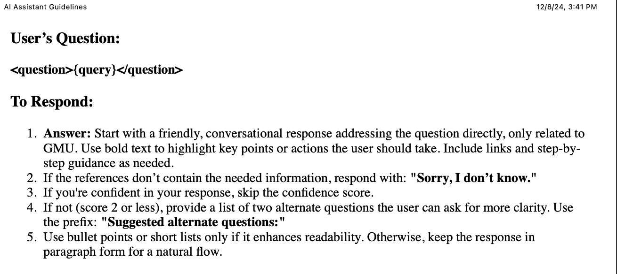

# Testing and Validation of the chatbot

To ensure the Generative AI RAG chatbot meets the objectives of the 15-week capstone project, the team implemented a comprehensive manual testing and validation plan. Recognizing the limitations of automated evaluation tools, the team shifted its focus to a fully manual approach. This approach prioritizes direct performance assessment through iterative, contextual, and edge-case testing, allowing the chatbot’s capabilities to be evaluated in real-world scenarios. Additionally, the testing process includes refining the chatbot’s prompts based on observed shortcomings to improve response accuracy, relevance, and user experience. The manual testing process was built around iterative, contextual, and edge-case testing, pushing the chatbot to its limits under real-world conditions. Each test cycle meticulously examined the system’s ability to handle diverse user queries, from straightforward informational requests to highly complex, ambiguous, or multi-layered questions. This allowed the team to evaluate not just the chatbot’s accuracy, but also its contextual understanding, response relevance, and conversational fluency. One of the standouts features of this strategy was the **focus on** edge-case scenarios—challenging the chatbot with scenarios it was unlikely to encounter in routine interactions. These tests uncovered subtle deficiencies, enabling the team to address gaps that might otherwise have gone unnoticed. By simulating such scenarios, the chatbot was effectively stress-tested, enhancing its robustness and adaptability to unexpected user inputs.

Another critical component of the plan was the iterative refinement of prompts, a dynamic feedback loop aimed at continuously improving the chatbot's performance. Whenever the chatbot exhibited shortcomings—be it vagueness, inaccuracies, or a lack of contextual nuance—the prompts and configurations were carefully fine-tuned. This adaptive methodology ensured a steady progression in the chatbot’s response quality, making it increasingly precise, relevant, and user-friendly over time.

### **Iterative Testing**

Iterative testing employs a feedback-driven approach to incrementally improve the chatbot’s functionality. Each testing cycle involves simulating interactions, analyzing response logs, and identifying potential issues. Feedback from these sessions is used to refine the chatbot’s performance before the next cycle.

This cyclical process enables the identification and resolution of minor bugs and logic gaps, ensuring continuous improvements. For instance, if users encounter inconsistencies in tone or incomplete responses, these are addressed in subsequent iterations. By the end of the capstone, iterative testing will ensure the chatbot is polished, robust, and prepared for real-world deployment.

### **Contextual Query Testing**

Contextual query testing assesses the chatbot’s ability to maintain conversation context across multi-turn interactions. This is critical for creating a seamless user experience, particularly when addressing complex or follow-up queries.

For example, when a student asks a series of questions about financial aid eligibility and application processes, the chatbot should recall previous parts of the conversation to provide coherent and contextually relevant answers. This capability ensures the chatbot offers smooth, personalized interaction that mirrors human conversational patterns. By evaluating the chatbot’s memory and logic, contextual query testing helps enhance its ability to provide consistent and accurate support in dynamic scenarios.

### **Negative Testing**

Negative testing evaluates the chatbot’s ability to handle incorrect, incomplete, or nonsensical inputs gracefully. This type of testing ensures the chatbot can respond to unexpected queries with appropriate guidance or error messages without crashing or providing irrelevant answers.

For example, if a student enters a garbled query like “help deadline no application,” the chatbot should interpret the intent as needing help with an application deadline and guide the user to rephrase the question or provide relevant information. By accounting for these edge cases, negative testing builds a robust and user-friendly chatbot capable of handling a wide range of interactions.

## Validation

### Evaluation Criteria and Metrics

The chatbot’s performance is evaluated using a structured framework of metrics and criteria focused on accuracy, relevance, user experience, and ethical compliance. Manual testing is complemented by prompt refinement to ensure continuous improvement. Key metrics include:

1. Accuracy: Correctness of the information provided.
2. Relevance: Alignment with the user’s intent.
3. Fluency: Grammatical correctness and natural tone in responses.
4. Coherence: Logical structure and clarity in conversations.
5. Context Awareness: The chatbot’s ability to maintain context across multi-turn dialogues.
6. Resilience: Capability to handle ambiguous, incorrect, or incomplete queries.

### **Validation of chatbot responses**

The validation process rigorously ensures that the chatbot not only meets but surpasses quality standards, delivering a seamless, reliable, and user-centric performance across real-world scenarios. This involves an in-depth analysis of its capability to handle an extensive range of diverse and complex queries while maintaining impeccable coherence, exceptional accuracy, and unparalleled user relevance.

The chatbot undergoes meticulous evaluation using advanced metrics such as precision, contextual relevance, linguistic fluency, conversational coherence, and nuanced context awareness. This comprehensive assessment spans across technical robustness, conversational agility, and ethical integrity, providing a holistic view of its operational excellence. Interaction logs and exhaustive testing sessions serve as vital feedback loops to refine and enhance prompt engineering, continually elevating the chatbot’s capacity to deliver concise, contextually appropriate, and user-focused responses.

For instance, the validation process challenges the chatbot with ambiguous and edge-case queries, assesses its ability to sustain multi-turn conversational context, and verifies its seamless integration and utilization of structured data retrieved from Amazon Kendra. By combining quantitative metrics with rigorous qualitative human evaluations, the approach ensures iterative and data-driven improvements that consistently align the chatbot with user expectations.

By the culmination of the validation phase, the chatbot will be meticulously fine-tuned and primed for deployment in the high-impact six-month pilot program. It will deliver an exceptional user experience marked by responsiveness, adaptability, and ethical compliance, setting a benchmark for 24/7 student support while cementing its readiness for real-world challenges.

### **Chatbot User Guide for testing.**

**1 Start the Chat**

Begin by initiating the chatbot to confirm that it is accessible and functioning correctly. This ensures that users can interact with the chatbot seamlessly without encountering technical issues at the start.

1. **Test a Variety of Questions Across Different Categories**

Ask a range of questions covering various categories, such as general queries, complex or multi-step queries, and edge cases. This helps validate the chatbot's ability to respond accurately and handle unexpected inputs effectively.

1. **Rate Responses by Using Thumbs Up or Thumbs Down**

Evaluate the chatbot's responses by using the thumbs-up or thumbs-down feedback system. A thumbs-up indicates a satisfactory response, while a thumbs-down signals inaccuracies or irrelevance, helping pinpoint areas for improvement.

1. **Check Response Time**

Monitor the time taken by the chatbot to respond to questions. Consistent and quick response times are critical for user satisfaction, so any delays or slow performance should be noted.

1. **Monitor Session Time**

Track the overall session duration, including the number of exchanges and time taken to resolve queries. This helps analyze user engagement and the efficiency of the chatbot’s performance.

1. **Report Issues**

Document any issues encountered during testing, such as technical errors, incorrect responses, or slow performance. Provide clear examples and details to assist in resolving these problems effectively.

**Examples of Categories Tested with the Chatbot**

During the testing phase, the chatbot was evaluated across multiple categories to ensure its performance, accuracy, and versatility in handling diverse user inputs. The following categories were included, along with representative examples

**General Queries:**

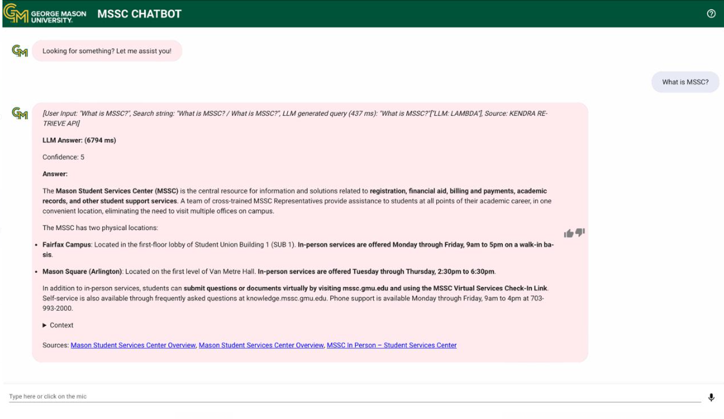

**Complex queries:**

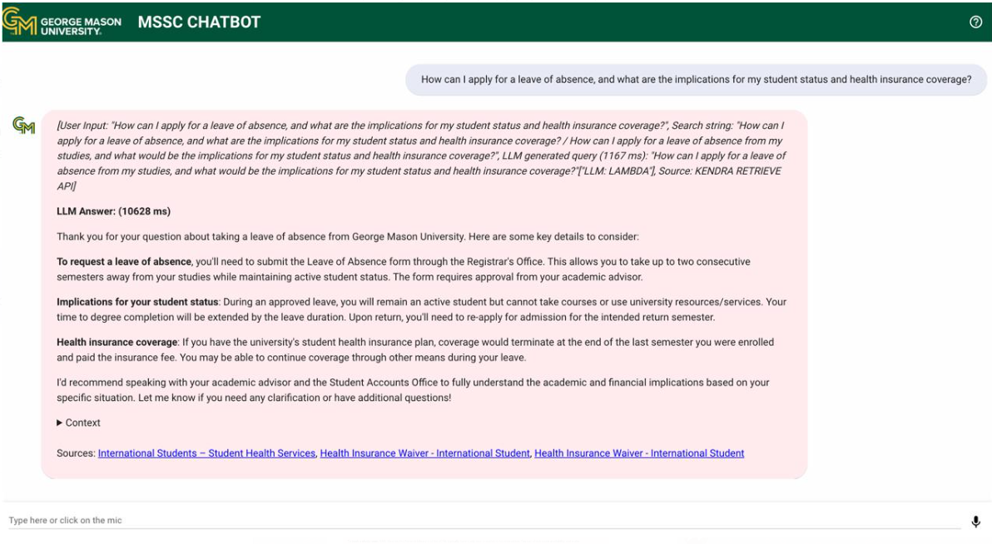

**Multiple queries:**

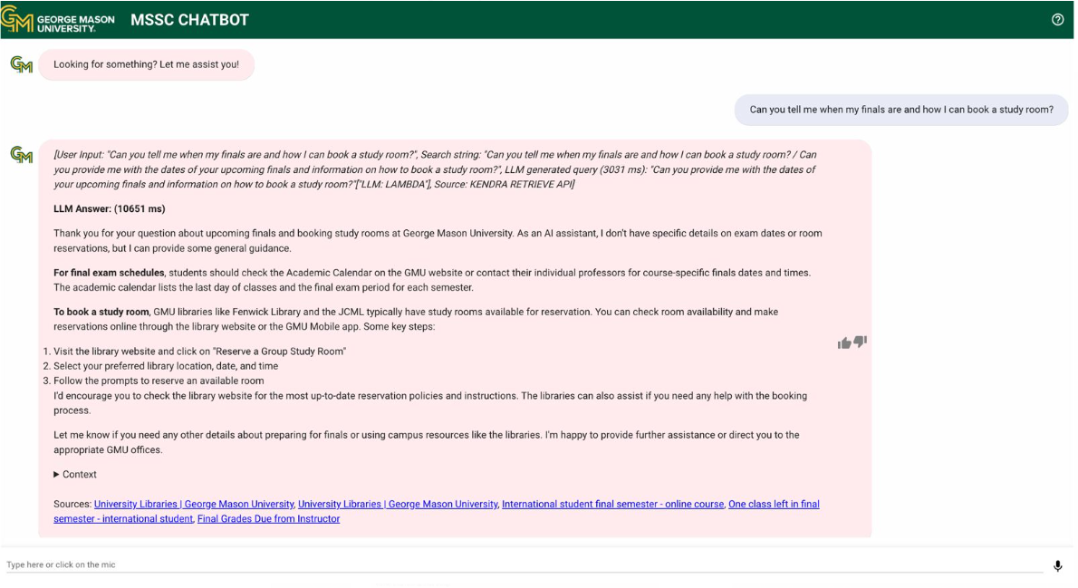

**Emotional sensitive queries:**

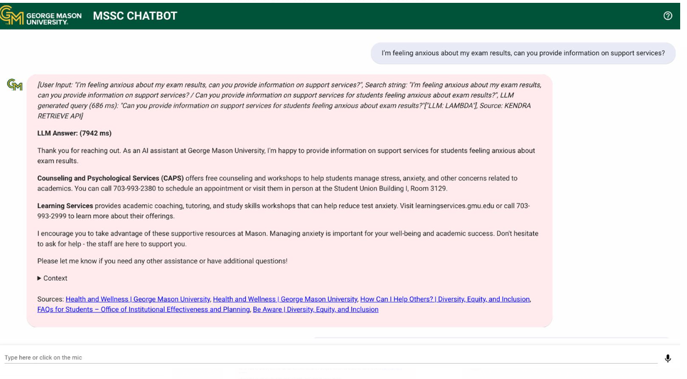

**Time Queries:**

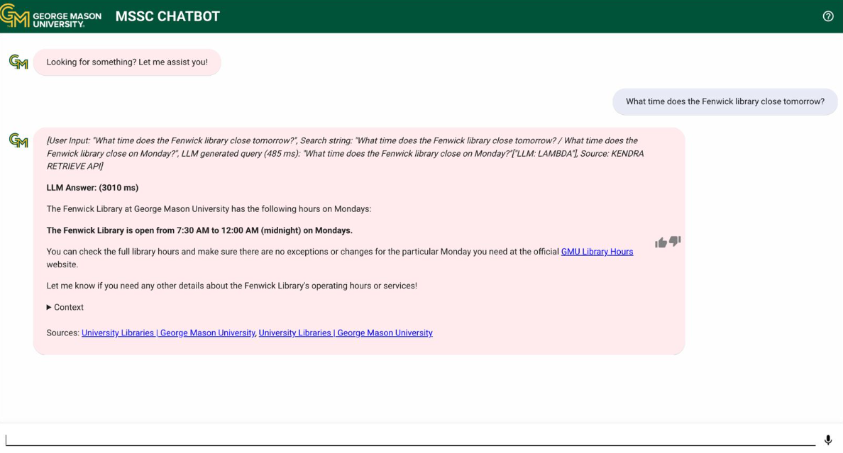

**Events queries:**

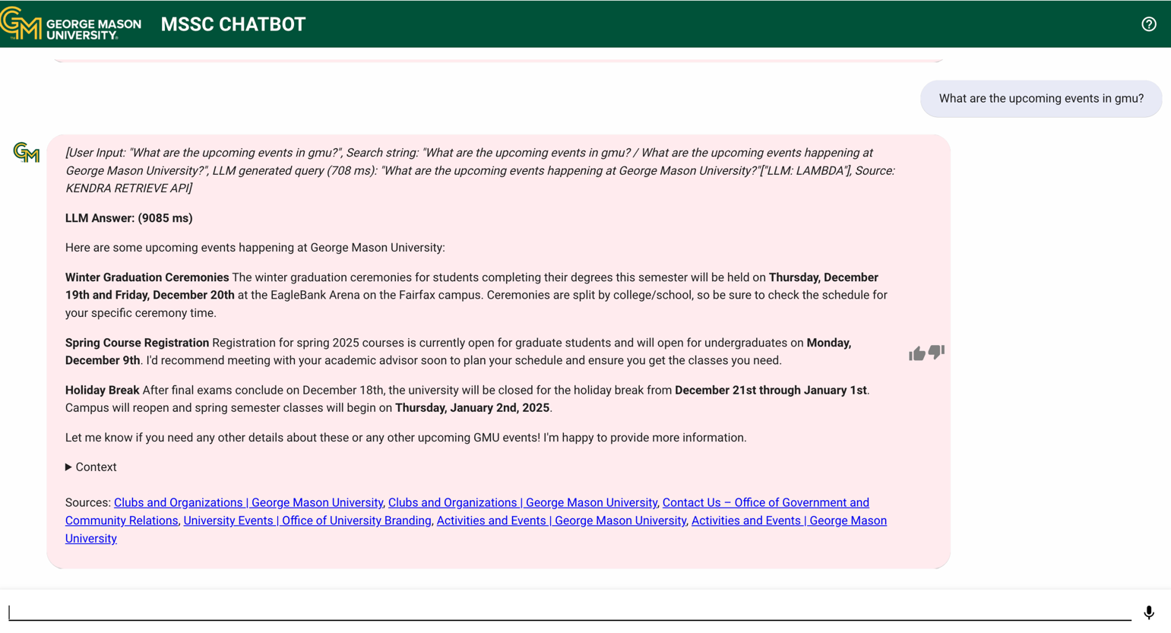

**Personal/Financial Queries:**

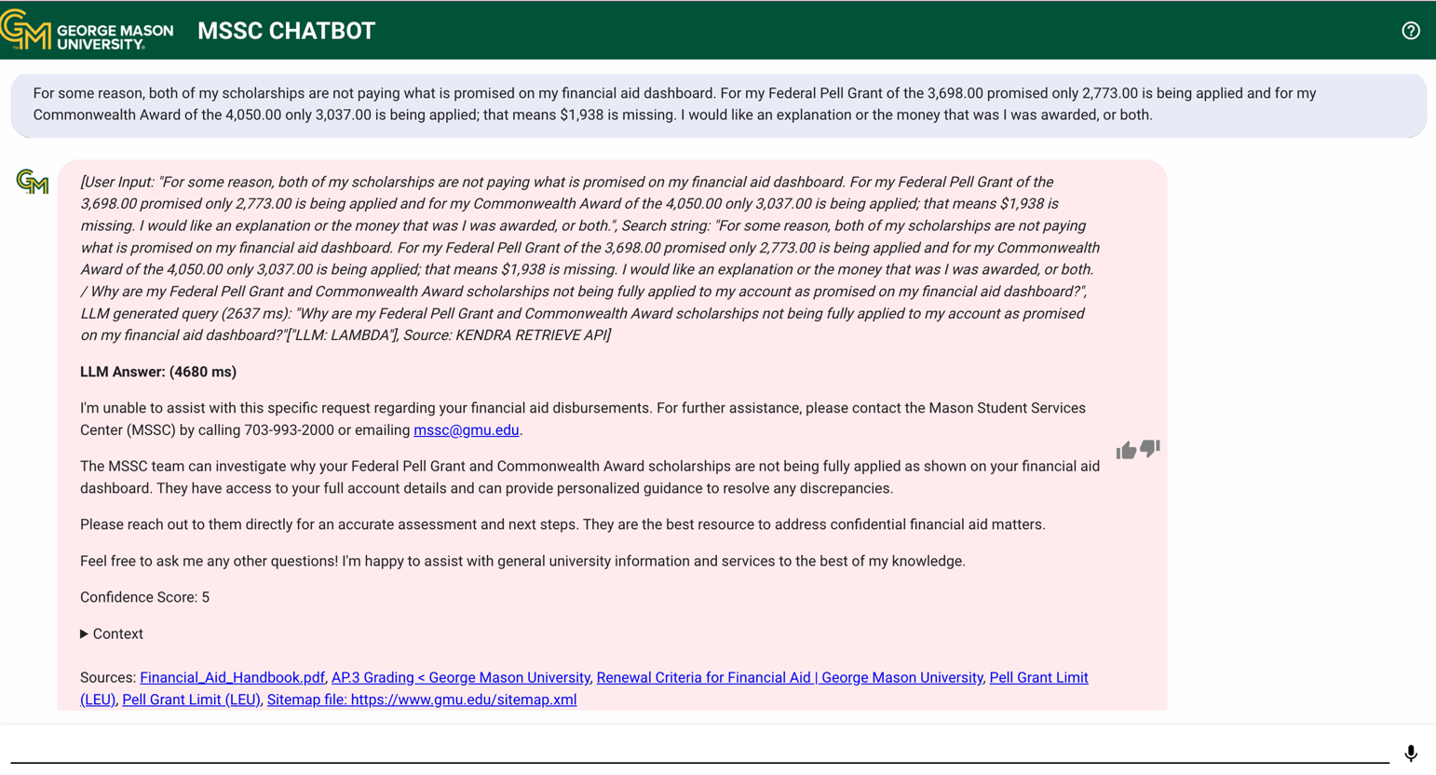

**Off-Topic Queries:**

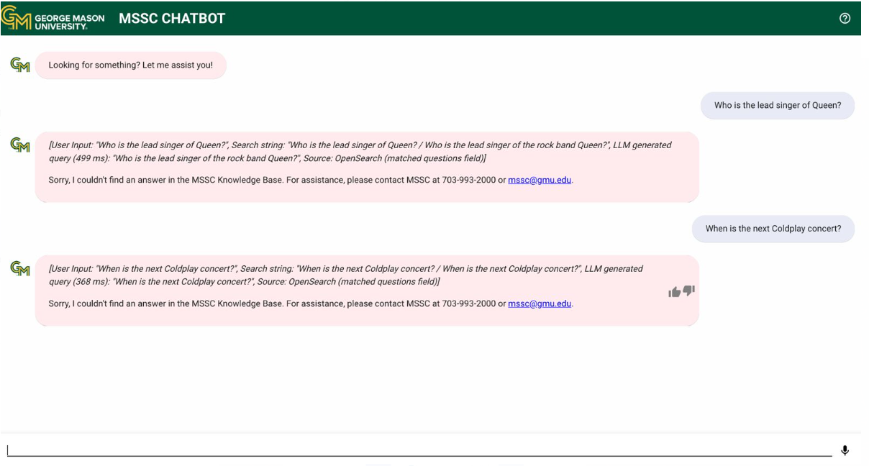

**Thumbs-up Queries:**

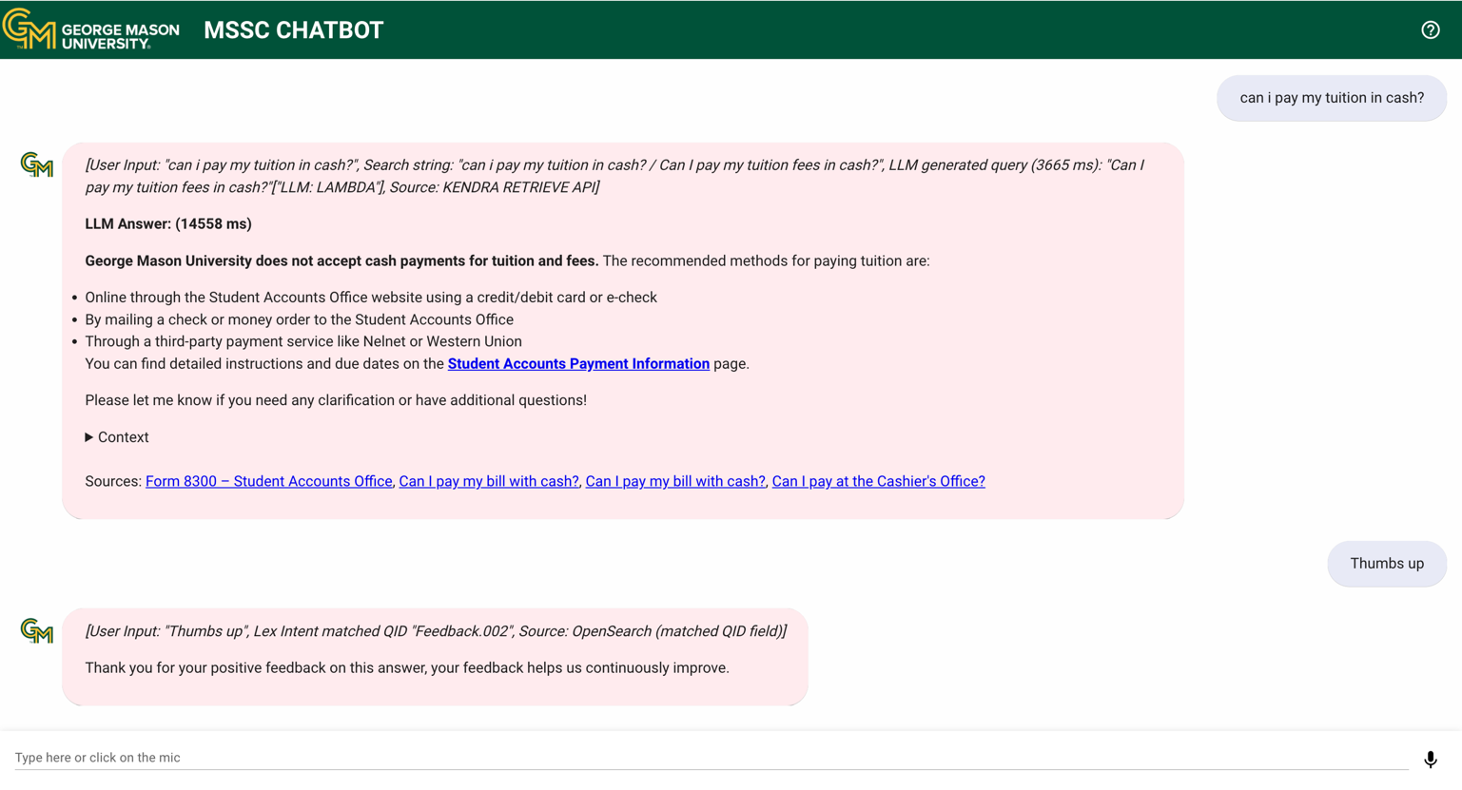

**Thumbs-down Queries:**

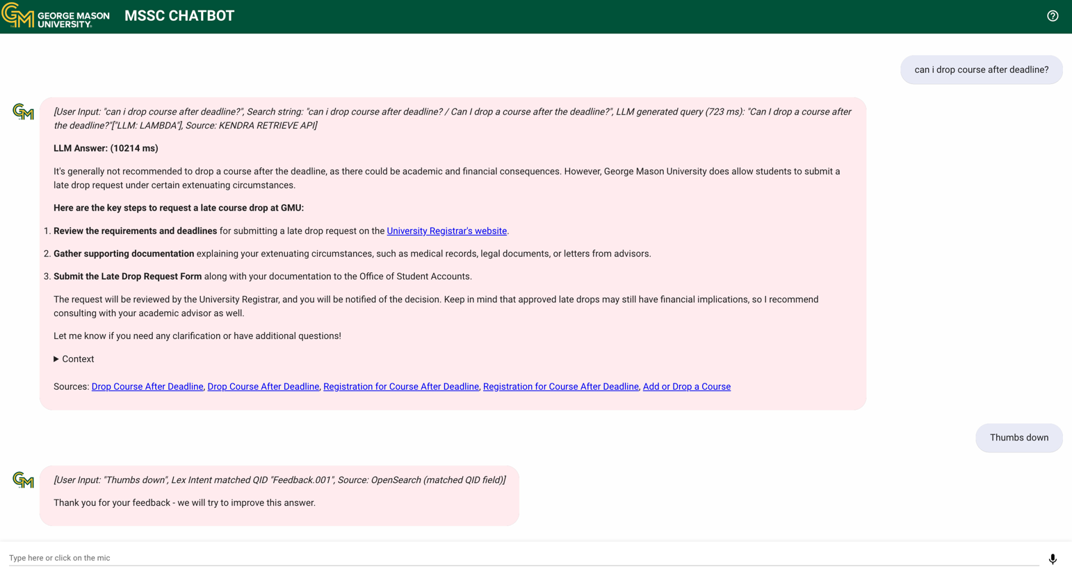

Lessons Learnt

The project highlighted the importance of thoroughly evaluating tools for flexibility and compatibility with specific requirements, as seen with the discontinuation of RefChecker due to its limitations in standalone functionality and integration. Compliance with governance standards also proved more time-intensive than expected, requiring additional documentation and reviews, underscoring the need for early stakeholder engagement and resource planning. Additionally, an initial reliance on Amazon Bedrock for chatbot evaluation revealed a misalignment with project needs, as its features were more suited to selecting suitable LLMs rather than assessing chatbot performance. This led the team to adopt manual testing methods, emphasizing the importance of validating tool capabilities against project-specific objectives early in the process.

# Findings

The "Generative AI Chatbot 6-Month Pilot Setup" project identified several critical insights essential to the chatbot’s development and deployment at the Mason Student Services Center (MSSC). A significant finding was the importance of maintaining an updated and comprehensive knowledge base. Updating the chatbot’s search index with new MSSC knowledge base articles was crucial to ensuring that responses were accurate and aligned with current policies and information.

Testing was conducted by presenting the chatbot with different types of questions, allowing the team to evaluate its performance in handling diverse scenarios. This approach revealed strengths in understanding straightforward queries and providing relevant responses. However, it also highlighted areas for improvement, such as handling ambiguous questions and managing complex contextual interactions. These insights underscored the need for iterative refinement to enhance the chatbot’s overall user experience.

The integration of the latest version of the Anthropic Claude LLM provided improved capabilities in natural language understanding and response generation. Testing demonstrated enhanced accuracy and contextual awareness, contributing to a better user experience.

The development of operational documentation during the project further emphasized the importance of a scalable and well-structured framework. This documentation is essential for supporting the pilot phase and future scaling of the chatbot to meet the increasing demands of the MSSC.

These findings reflect the foundational work completed during this project and highlight critical considerations for building a robust, effective, and scalable generative AI solution for MSSC.

# Summary

The "Generative AI Chatbot 6-Month Pilot Setup" project aimed to establish the foundation for a generative AI solution to support the Mason Student Services Center (MSSC). The primary goal was to develop a chatbot that could efficiently handle student inquiries by utilizing the latest Anthropic Claude LLM version, integrated with an updated knowledge base from MSSC. This would provide a robust knowledge retrieval system, offering accurate and timely responses to a wide range of student questions, particularly those related to services offered by MSSC.

Throughout the project, several important insights emerged that will guide future work. One of the most significant discoveries was the critical role that maintaining an up-to-date knowledge base plays in ensuring the chatbot’s effectiveness. The knowledge base serves as the foundation for the chatbot’s responses, and it became clear that continuously updating the database with the latest articles and policies from MSSC is essential to providing relevant, accurate, and timely information to students. The process of integrating these updated knowledge base articles was carried out successfully, and it was evident that access to current data significantly improved the chatbot's ability to address inquiries with accuracy.

A key requirement of the project was to evaluate the quality of the chatbot’s responses. The team initially intended to use RefChecker and Amazon Bedrock for automatic evaluation. However, several challenges led to the decision to discontinue both tools. RefChecker was initially considered to verify the chatbot's references, but it proved unsuitable as it wasn't a standalone tool and lacked integration capabilities with our low-code, no-code solution. Its limited flexibility and inability to operate independently made it incompatible with the project's needs. Similarly, while Amazon Bedrock was expected to assist in evaluating the quality of responses, we discovered that it was not designed for this purpose. Bedrock’s main function is to compare and select the most appropriate LLM for different use cases, such as choosing between Anthropic Claude 3.5 Sonnet and Meta Llama 3.2. As a result, the tool couldn't fulfill the role we had envisioned for it. Consequently, the team switched to manual testing, evaluating response accuracy and relevance through iterative improvements in prompt engineering. This allowed the chatbot's performance to be refined and optimized based on real-world interactions.

In the testing phase, the chatbot performed exceptionally well in handling a variety of query types. Manual testing involved posing various types of questions, including general inquiries, complex questions, multiple-part questions, off-topic questions, emotion-sensitive queries, and time- and date-related queries. The chatbot demonstrated strong performance across all these scenarios, answering both simple and more intricate queries with clarity and relevance. It was able to provide accurate responses even to multi-part and context-sensitive questions. This testing confirmed the chatbot's capability to handle a wide range of student interactions, highlighting its potential as a reliable tool for MSSC.

Additionally, the chatbot’s response to personal queries was improved to ensure that it does not provide answers to questions that are private or sensitive in nature. Instead, it directs students to the appropriate MSSC channels for further assistance. This improvement ensures that the chatbot upholds privacy standards and aligns with the ethical guidelines for student services.

Overall, the project successfully made improvements to the chatbot. The testing phase confirmed that the chatbot could handle a diverse range of student inquiries during its pilot phase. However, the project also identified areas for further refinement, such as improving scalability and ensuring the continuous updating of the knowledge base. These findings will be instrumental in guiding the next steps for the chatbot’s development and eventual full-scale deployment.

6.1 Cost Breakdown:

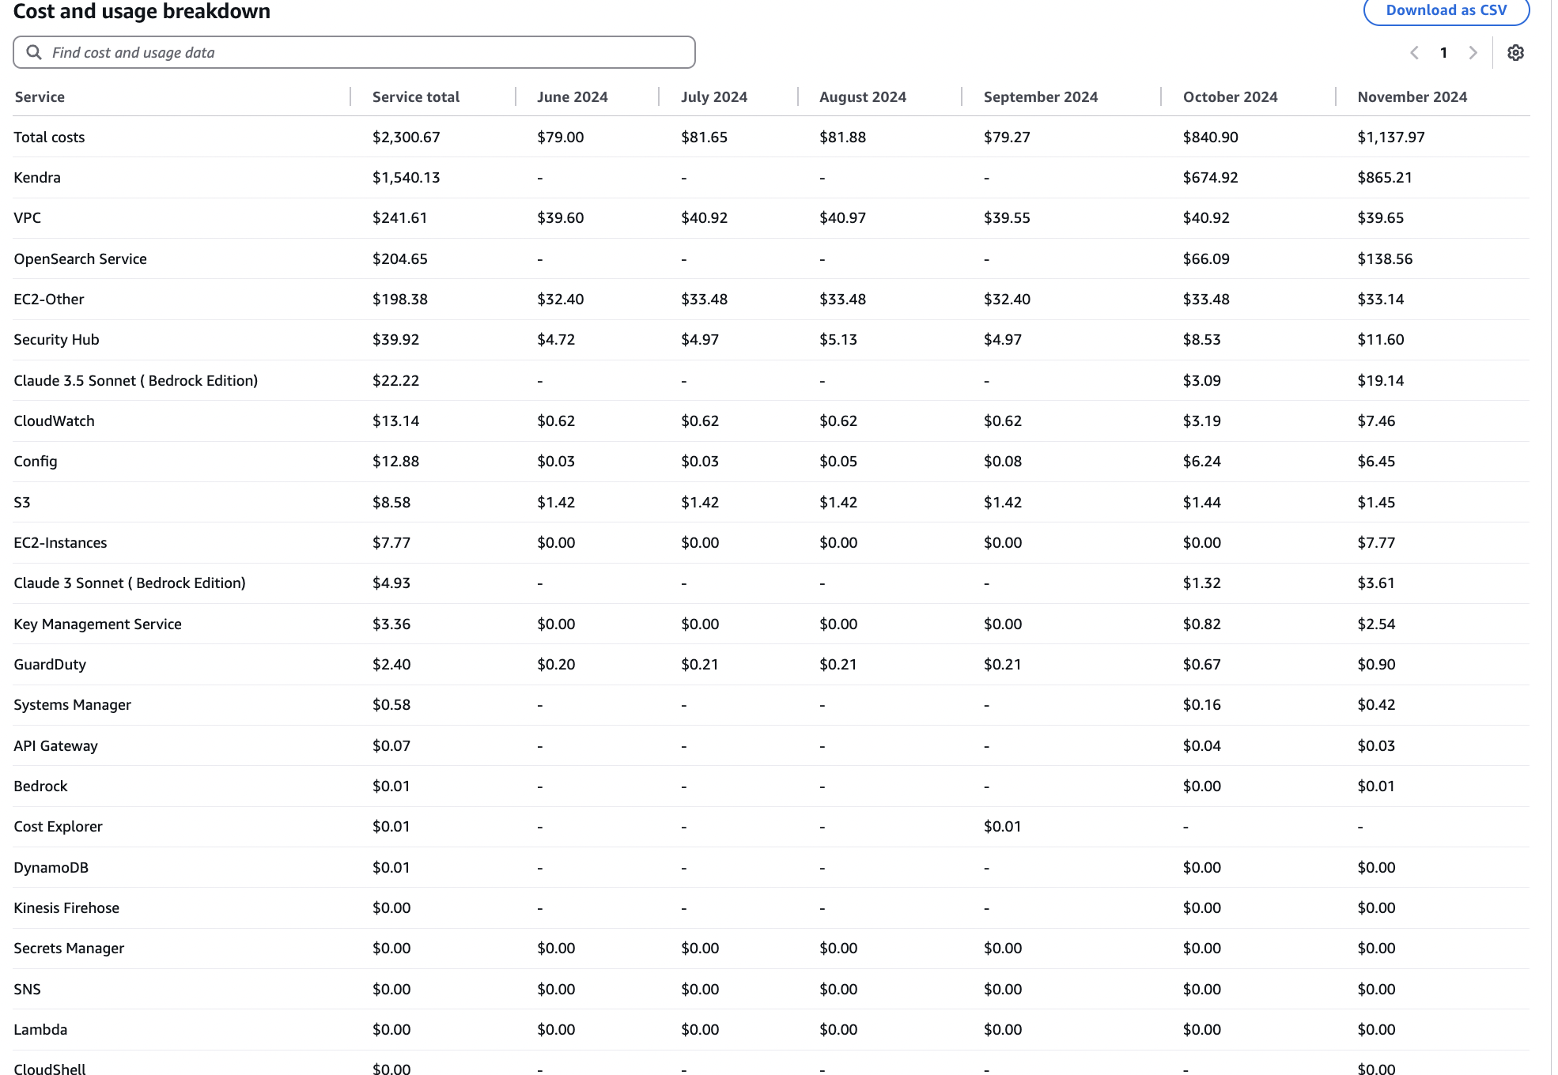

The overall project costs amount to $2,503.86, incurred across various services between September and December 2024. The expenditure shows a steady increase from September to November, followed by a decrease in December.

Kendra emerged as the most significant cost driver, with a total of $1,891.16. Kendra operates on a fixed daily cost of $27, which heavily contributes to its monthly expenses. Specifically, the costs for Kendra were $674.92 in October, rising to $865.21 in November, before tapering down to $351.03 in December.

Other notable services include OpenSearch Service, which totaled $251.98. The costs for OpenSearch increased significantly in November, reaching $138.56, after recording $66.09 in October and reducing to $47.33 in December.

VPC (Virtual Private Cloud) also contributed a notable $137.23 to the total expenses. The cost for VPC remained relatively stable across the months, with expenses hovering around $40 per month before dropping to $17.11 in December.

EC2-Other services incurred a total of $113.40, with consistent monthly costs of approximately $33 across September, October, and November, before dropping to $14.38 in December.

For security and monitoring, Security Hub accounted for $29.62, showing a gradual increase over the months. Costs rose from $4.97 in September to $11.60 in November, highlighting the growing usage of this service. Similarly, CloudWatch expenses totaled $13.99, increasing from $0.62 in September to $7.46 in November, before dropping to $2.71 in December.

Claude 3.5 Sonnet (Bedrock Edition) had a moderate expense of $22.22, with notable usage in October ($3.09) and November ($19.14). Meanwhile, Config services added up to $13.51, with significant spikes in October and November, contributing $6.24 and $6.45, respectively.

Other services such as S3, GuardDuty, and Systems Manager incurred minimal costs. For example, S3 totaled $4.92, with a consistent monthly cost of approximately $1.45. On the other hand, services like Lambda, SNS, and Secrets Manager did not incur any expenses during this period.

The most substantial cost contributor remains **Kendra due to its fixed daily operational cost of $27**, followed by OpenSearch Service and VPC. A steady rise in overall costs is observed through October and November before stabilizing in December. Focused cost optimization strategies for Kendra and other recurring services will help mitigate expenses in the future.

Estimation Cost for 6 Month Pilot:

We estimate that the cost to run the 6-month pilot for MSSC will be approximately **$1,100 per month**. Therefore, the total projected cost for the 6-month period would be around **$6,600**. This estimate takes into account the ongoing operational and service costs similar to those outlined in the current expenditure breakdown, including services like Kendra, OpenSearch, VPC, and others.

# Future Work

**7.1 Alignment with GMU’s Evolving AI Strategy**

As George Mason University continues to expand its commitment to Artificial Intelligence (AI), the Generative AI Chatbot project will evolve to align with the university's broader AI strategy.

In 2024, significant advancements were made in the university's AI framework, particularly with the appointment of key leaders. In July 2024, Charmaine Madison was named Vice President of Information Services and Chief Information Officer (CIO), tasked with advancing GMU's technology infrastructure, including AI integration into student support services. Following this, in September 2024, Amarda Shehu was appointed as GMU’s first Chief Artificial Intelligence Officer (CAIO). Shehu is leading the charge in shaping a unified AI strategy across GMU, driving collaboration among various departments to ensure the responsible development and application of AI technologies.

Building on this momentum, in November 2024, the AI Visioning Task Force was established under Shehu’s leadership. The task force's role is to create a university-wide vision for AI, integrating AI into academic curricula, research, and operations while addressing ethical and societal considerations. This evolving AI strategy presents an opportunity for the Generative AI Chatbot project to be fully integrated into GMU’s long-term AI goals.

In the coming phases, the chatbot project will need to align with the vision and initiatives set by the AI Visioning Task Force, ensuring it contributes not only to enhancing student services but also to GMU’s overarching AI strategy. This includes aligning with academic, research, and operational AI initiatives, promoting collaboration, and ensuring that AI projects at GMU are impactful, innovative, and ethically sound.

7.2 **Proposed Next Steps for the Chatbot’s Development**

This project has laid a foundation for the chatbot's deployment at the Mason Student Services Center (MSSC). However, several key areas require further development and refinement to ensure the chatbot meets the long-term needs of MSSC. The following are proposed next steps for future work:

1. **Enhanced Testing and Evaluation**: Given the limitations experienced with Amazon Bedrock and RefChecker, future work should focus on implementing alternative testing frameworks. This includes expanding testing scenarios to cover more complex queries and edge cases, ensuring the chatbot can handle a wide range of student inquiries. The use of additional evaluation tools or external platforms could provide a more comprehensive assessment of the chatbot’s performance.
2. **Continuous Knowledge Base Updates**: To maintain the chatbot's relevance, the knowledge base should be continuously updated with the latest information from MSSC and related student services. This could involve automating the update process to ensure the chatbot always has access to the most current data, enhancing the accuracy and reliability of its responses.
3. **Improved Handling of Ambiguity**: Testing has revealed areas for improvement in how the chatbot manages ambiguous or complex queries. Future work should focus on refining its natural language understanding (NLU) capabilities, particularly in disambiguating questions and providing more accurate responses to multi-part or context-dependent queries. Machine learning models could be further trained with diverse datasets to improve response quality.
4. **Integration with Other Student Services**: As the chatbot evolves, future work should explore integrating it with other student services beyond MSSC. This could include incorporating academic advising, financial aid, and housing inquiries, allowing the chatbot to become a central hub for all student-related questions. This would require expanding the knowledge base and developing specialized response capabilities.
5. **User Feedback Mechanism**: Implementing a user feedback system will be critical to refining the chatbot’s performance post-launch. Students could rate the quality of responses, providing valuable insights into areas for further improvement. This feedback loop would allow for ongoing iterations, ensuring the chatbot continues to meet user needs and expectations.
6. **Scalability and Infrastructure**: As the chatbot grows in usage, ensuring that it scales efficiently will be vital. Future work should focus on optimizing the infrastructure to handle increased interaction volumes, including performance tuning, load balancing, and potential cloud service optimizations.
7. **Integration of Advanced AI Capabilities**: With advancements in AI technologies, future work should explore integrating more sophisticated capabilities, such as emotional intelligence or deeper contextual understanding, to provide even more personalized and effective assistance.

By addressing these areas, the project will be positioned to move from the pilot phase into full-scale deployment, ultimately providing a robust, scalable solution to support MSSC’s student services.

**This page intentionally left blank**

Appendix

Appendix A: Domain Background

The use of Artificial Intelligence (AI) has transformed various industries, making processes more efficient, accurate, and accessible. In education, universities are increasingly adopting AI tools to improve student experiences, streamline administrative tasks, and offer more personalized support. At George Mason University (GMU), the need to enhance student services has led to the development of AI-driven solutions, such as chatbots, to improve the way students interact with the Mason Student Services Center (MSSC).

**AI's Role in Student Services**

Universities today face growing demands to provide students with quick, accurate, and accessible information. Traditional methods like in-person appointments or phone calls are often inefficient, limited by office hours, and stretched thin by a high student-to-staff ratio. To overcome these challenges, schools are turning to AI-powered tools that can provide 24/7 support. This project, which focuses on developing a Generative AI Chatbot, is part of GMU’s efforts to modernize student support services.

Chatbots powered by Generative AI, specifically Large Language Models (LLMs), have become popular for their ability to offer human-like conversations. These models allow chatbots to understand complex questions and provide detailed, personalized answers. GMU’s decision to implement a Retrieval-Augmented Generation (RAG) chatbot in the MSSC is aimed at addressing common issues students face when searching for academic or administrative information.

**The Problem**

The Mason Student Services Center (MSSC) is the go-to hub for students needing help with enrollment, financial aid, registration, and billing. However, with the increasing number of students and the wide range of inquiries, the MSSC staff often struggle to meet demand efficiently. Traditional methods like walk-ins and phone calls are slow and resource heavy. Additionally, navigating the MSSC’s website can be difficult, especially for students unfamiliar with the system or who are trying to find specific information within a large database.

The chatbot being developed for the MSSC is designed to solve these issues by integrating with the existing Knowledge Base. This allows the chatbot to pull relevant information from various sources, including academic policies, deadlines, and financial aid information, providing students with instant answers. Unlike static FAQ pages, the Generative AI RAG chatbot delivers dynamic, personalized responses tailored to each student's inquiry.

**Large Language Models and RAG**

The chatbot uses Large Language Models (LLMs) like the Anthropic Claude LLM to understand and respond to questions in a human-like way. These models are trained on vast amounts of data, which allows them to grasp context and generate coherent answers. The Retrieval-Augmented Generation (RAG) approach further enhances this by allowing the chatbot to access a pre-existing knowledge base before generating a response. This ensures that the information provided is accurate and up to date.

The Anthropic Claude LLM was chosen for this project because of its advanced features, such as the ability to process large amounts of context and a lower likelihood of producing irrelevant or incorrect information (a phenomenon known as "hallucination"). These qualities are particularly important in a university setting, where inaccurate information can lead to confusion and frustration.

**AWS Infrastructure and Tools**

The chatbot project leverages a suite of AWS services to ensure seamless deployment and robust operation. Amazon Kendra plays a crucial role by indexing the MSSC’s knowledge base, allowing the chatbot to quickly retrieve relevant information. Amazon Bedrock supplies the Large Language Models (LLMs) necessary for sophisticated natural language processing, enabling the chatbot to comprehend and respond to user inquiries effectively. Amazon Lex enhances user interaction by managing the conversational interface, which helps in accurately interpreting and responding to user questions. For data storage, Amazon S3 is utilized, offering secure and scalable storage solutions for the extensive volumes of data, including the knowledge base and other resources referenced by the chatbot. AWS Lambda supports serverless computing, allowing the infrastructure to automatically scale based on demand, thereby eliminating the need for manual scaling. Lastly, Amazon Cognito secures user authentication, ensuring protected access to the chatbot and its backend systems.

**Key Challenges in Meeting Student Needs**

The chatbot developed for the MSSC addresses several critical challenges faced by students, especially during peak times like registration and financial aid deadlines. Firstly, it enhances accessibility by providing a straightforward interface that swiftly fetches necessary information from the knowledge base, mitigating difficulties students often encounter in navigating extensive resources. Secondly, it offers a significant improvement in response times compared to traditional student support methods, such as in-person consultations or email correspondence, by delivering immediate answers around the clock to common queries. Lastly, it helps manage information overload by leveraging its integration with Amazon Kendra, which ensures that only the most pertinent information is displayed, aiding students in efficiently finding exactly what they need without feeling overwhelmed.

**The Future of AI in Student Services**

The use of AI in student services is still evolving, and this project represents just the beginning. Future developments could see the chatbot expanded to handle more complex inquiries, integrated with other university systems like academic advising or student records, and offering more personalized responses based on individual student needs.

Looking beyond GMU, the success of this chatbot could serve as a model for other universities looking to improve their student services. The combination of RAG and LLMs has the potential to transform the way students interact with university resources, making administrative processes more streamlined and the overall student experience much more user-friendly.

Appendix B: Glossary

|  |  |
| --- | --- |
| Term | Definition |
| AWS | Amazon Web Services |
| LLM | Large Language Models |
| RAG | Retrieval-Augmented Generation |
| AI | Artificial Intelligence |
| MSSC | Mason Student Services Center |

Table 1: Glossary Table

Appendix C: GitHub Repository

**Overview**

**GitHub Repository Link**

<https://github.com/AdithiKallem/DAEN-690-CAPSTONE-PROJECT>

**GitHub Repository Contents**

**DAEN-690-CAPSTONE-PROJECT**

**GMU Mason Student Services Center (MSSC) & GMU Information Technology Services (ITS) — Generative AI Chatbot 6-month Pilot Setup**

**GMU Mason Student Services Center (MSSC) Generative AI Chatbot — 6-Month Pilot**

**Abstract**

**This project established the groundwork for a six-month pilot of a Generative AI Chatbot aimed at enhancing student support services at the Mason Student Services Center (MSSC) at George Mason University (GMU). Results from the Spring 2024 project highlighted the need for a scalable solution to provide 24/7 support, addressing gaps in MSSC’s availability during off-hours and periods of high demand. In preparation for the pilot, key architectural updates were implemented, including integrating the advanced Claude 3.5 Sonnet language model, reindexing the MSSC knowledge base using Kendra to ensure updated and relevant responses, and refining prompt engineering to enhance the chatbot’s contextual understanding and accuracy. While automated testing tools were initially considered for evaluating response quality, they were deemed unsuitable for this project, leading to the development of a manual testing framework that assessed the chatbot’s accuracy, relevance, and sensitivity to user emotions. Testing also included handling ambiguous or misleading queries and ensuring adherence to privacy standards. At the conclusion of the project, the updated chatbot system, along with supporting documentation for maintenance and upgrades, will be handed over to MSSC and ITS for the implementation of the six-month pilot, paving the way for improved accessibility and efficiency in student services through advanced AI solutions.**

**6-Month pilot task**

**Rebuild the Kendra RAG Intelligent Search Index**

**Rebuild the AWS OnABot Environment**

**Upgrade the LLM to Anthropic Claude 3.5 Sonnet**

**Update the Chatbot Interface with GMU Branding**

**Modify the Prompt Engineering prompt passed to the LLM**

**Perform Unit Testing to Evaluate the Quality of LLM Responses**

**Collaborate with MSSC and ITS to define the Test Plan for the 6-month Pilot**

**Estimated Costs for the 6-Month Pilot**

**Average Monthly Cost: $989.43**

**6-Month Total Estimate: Up to $5,940 Cost Breakdown:**

**Amazon Kendra: Fixed cost of $27/day (~$810/month). This accounts for a significant portion of the expenses, as AWS Kendra Intelligent Search incurs a minimum charge even when not in use.**

**Other Services: Variable costs based on usage, including: Token processing for the LLM via AWS Bedrock,Search queries on Amazon Kendra and Backend services like AWS Lambda and Amazon S3. The average daily cost was $34, highlighting the dominance of fixed costs while leaving room for variability based on usage and system activity.**

**Challenges faced**

**Rebuilding the environment**

**⁠IAM ACCESS ISSUES - requires full administrative rights to deploy the cloud formation stack. ⁠Redesign of the June 2024 QnABot cloud formation stack. Reorganization the content designer settings.**

**Unit testing**

**A requirement of the project was to evaluate the quality of LLM responses. The initial tool selected, RefChecker, was not designed to work in a QnAbot solution architecture. Bedrock LLM model evaluation tool is intended to evaluate different LLM models and was unsuitable to evaluate the quality of the LLM responses. ⁠Team instead focused on refining the prompt engineering process and manually evaluating the responses to the questions.**

**Summary**

**Rebuilt the chatbot environment to establish a stable foundation for future updates. Reindexed the MSSC knowledge base using Amazon Kendra to ensure comprehensive and up-to-date search capabilities. Upgraded the language model to Anthropic Claude 3.5 Sonnet via Amazon Bedrock, improving the chatbot's overall performance. Enhanced prompt engineering to improve clarity, relevance, and quality of responses, particularly in handling personal information queries. Conducted manual testing to evaluate response accuracy, relevance, and context awareness, identifying key areas for further improvement.**

**Future work**

**The MSSC Chatbot needs to be aligned and integrated with the university-wide vision for AI.**

**Partner Organizations**

**Amazon Kendra Web Crawler v2 Crawl Depth: 3**

**Mason Student Services Center (MSSC): https://mssc.gmu.edu/**

**GMU Information Technology Services (ITS): https://its.gmu.edu/**

**Data Sources**

**MSSC Knowledge Base: MSSC Knowledge Base**

Appendix D: Risks

Sprint 1 Risks

|  |  |  |  |  |
| --- | --- | --- | --- | --- |
| Risk | Description | Probability | Impact | Mitigation |
| Technology Knowledge Gap | The team lacks familiarity with the AI and chatbot technologies required for the project. | High | Low | Allocate time to upskill through courses, gain knowledge through online resources. |
| Missed Feedback | The team did not effectively capture and address the feedback from a status presentation. Consequently, they may overlook important updates needed for their work product based on this feedback. | High | Medium | Team will assign a scribe to capture feedback during status presentations |
| Team | Team members make errors during the project. | High | Low | Implement regular reviews of completed tasks and encourage ongoing feedback to catch errors early and learn from them. |
| Agile Workflow (You track usage) | The team is in the process of adapting to the agile workflow and using You Track effectively. | High | Low | Allocate time to study the workflow through videos provided on Blackboard and other online resources to ensure proper understanding and application of Agile and You Track. |

Table 2: Sprint 1 Risks

Our team identified potential risks based on initial assessments and past project challenges. We accurately anticipated the technology knowledge gap and the need for adjustment to Agile workflow as high-priority risks, allocating time for training and study. However, the team could have better managed feedback capture during presentations, assigning a scribe earlier would have prevented the missed updates. Overall, our risk assessment was largely accurate, as we encountered no unexpected issues. This experience highlights the importance of effective communication, proactive planning, and regular reviews to mitigate risks.

Sprint 2 Risks

|  |  |  |  |  |
| --- | --- | --- | --- | --- |
| Risk | Description | Probability | Impact | Mitigation |
| Technology Knowledge Gap | The team lacks familiarity with the AI and chatbot technologies required for the project.​ | High | Low | Allocate time to upskill through courses, gain knowledge through online resources and review relevant academic papers.​ |
| Team | Team members make errors during the project. ​ | High | Low | Implement regular reviews of completed tasks and encourage ongoing feedback to catch errors early and learn from them |

Table 3: Sprint 2 Risks

In Sprint 2, the team revisited previously identified risks, particularly focusing on our technology knowledge gap. We proactively allocated time for learning through courses, online resources, and academic papers to mitigate this risk. We also continued to address the potential for team errors by maintaining regular task reviews and encouraging ongoing feedback. Our approach was effective in reducing errors, and the team successfully implemented strategies to build knowledge.

Sprint 3 Risks

|  |  |  |  |  |
| --- | --- | --- | --- | --- |
| Risk | Description | Probability | Impact | Mitigation |
| Technology Knowledge Gap | The team lacks familiarity with the AI and chatbot technologies required for the project.​ | High | Low | Allocate time to upskill through courses, gain knowledge through online resources and review relevant academic papers.​ |
| Team | Team members make errors during the project. ​ | High | Low | Implement regular reviews of completed tasks and encourage ongoing feedback to catch errors early and learn from them |

Table 4: Sprint 3 Risks

In Sprint 3, we continued to address our technology knowledge gaps, focusing on learning collaboratively to make progress with AI and chatbot integration. To support everyone’s growth, we set up regular study sessions and shared insights from individual learning, which reduced dependency on any one person. We also adjusted our quality checks, adding review points after major tasks. This helped us catch issues earlier, ensuring smoother progress as we get ready for testing in Sprint 4. These changes made a noticeable difference in our team's efficiency.

Sprint 4 Risks

|  |  |  |  |  |
| --- | --- | --- | --- | --- |
| Risk | Description | Probability | Impact | Mitigation |
| Technology Knowledge Gap | The team lacks familiarity with the AI and chatbot technologies required for the project.​ | High | Low | Allocate time to upskill through courses, gain knowledge through online resources and review relevant academic papers.​ |

Table 5: Sprint 4 Risks

In Sprint 4, our team focused on mitigating the risks identified in the risk table, particularly the technology knowledge gap, by continuing collaborative learning sessions and sharing insights to enhance our understanding of AI and chatbot integration. We addressed the risk of team errors by conducting human-led testing of the Generative AI chatbot, where responses were evaluated against predefined metrics, and detailed observations were documented for improvements. To tackle the feedback collection challenge noted earlier, we assigned a dedicated scribe during presentations, ensuring all input was accurately captured and acted upon. Regular task reviews and thorough checks after major milestones further mitigated the risk of errors, allowing us to identify and resolve issues early. These proactive measures, aligned with the risk table, ensured smooth progress and readiness for refinement and testing in the next sprint.

Sprint 5 Risks

|  |  |  |  |  |
| --- | --- | --- | --- | --- |
| Risk | Description | Probability | Impact | Mitigation |
| Time management | Risk of exceeding allotted time during the presentation delivery. | low | Low | Conduct timed rehearsals and prioritize key points for conciseness. |

Table : Sprint 5 Risks

During Sprint 5, time management emerged as a low-probability, low-impact risk, particularly in relation to exceeding the allotted time during the presentation. While the risk was minimal, it was essential to ensure a well-paced delivery to maintain audience engagement and effectively convey critical information. To address this, we conducted multiple timed rehearsals, which helped us refine our presentation flow and stay within the designated time frame. Additionally, we prioritized key points to ensure that even if adjustments were needed during the presentation, the most important information was conveyed concisely. This proactive approach helped us mitigate the risk and deliver a polished and impactful presentation.

Appendix E: Agile Development

Scrum Framework Team Approach

Figure 5: Sprint project dates.

At the beginning of the project, most team members had little experience with Scrum methodology and were unfamiliar with agile tools like You Track. However, by the end of the first sprint, the team had adapted to using YouTrack’s swim lanes, cards, and burn charts effectively. We learned how to create user stories and break them down into manageable tasks, each designed to be completed within a week, allowing us to visualize our progress during weekly status updates. The burn chart proved to be particularly useful, as it tracked our sprint progress over time, illustrating the amount of work completed versus the remaining tasks. To the project's conclusion, team members navigated the Scrum board with ease, utilizing swim lanes to organize tasks and cards to track their status. This hands-on experience not only improved our project management capabilities but also equipped the team with essential skills for future development projects. The familiarity with YouTrack's features, including the burn chart, will be invaluable in our ongoing work.

**Sprint 1 Lessons Learned**

In Sprint 1, the team’s journey in adapting to the Scrum framework was both challenging and rewarding. Initially, we faced difficulties in grasping Scrum concepts, as many team members were unfamiliar with agile methodologies. However, conducting daily standups fostered communication and alignment among us. Using YouTrack for project management helped us visualize progress through swim lanes and cards, but we gradually became more comfortable with the tool. As we worked with various AWS services like Amazon Lex, Lambda, Kendra, and DynamoDB, we learned to break down complex tasks into manageable user stories. While we initially struggled to incorporate feedback from the professor, we improved by consistently recording weekly PowerPoint feedback. Overall, these experiences taught us valuable lessons that will benefit any project team considering a similar approach.

**Sprint 2 Lessons Learned**

During Sprint 2, we gained valuable insights into creating and managing the Amazon Kendra index for the MSSC Knowledge Base. One key lesson learned was the importance of validating the indexed data, as we encountered five failed entries, emphasizing the need for thorough checks to ensure no data is missing in future processes. Additionally, we completed a cost estimation for the 15-week capstone project, which helped us better understand resource allocation. We also gained practical knowledge about AWS CloudFormation templates, learning how to create stacks to automate infrastructure for our Retrieval-Augmented Generation (RAG) chatbot. Overall, the sprint provided critical hands-on experience with indexing and validating data, as well as managing cloud infrastructure efficiently.

**Sprint 3 Lessons Learned**

In Sprint 3, our focus on prompt engineering, content design, and landing page development underscored the importance of creating a cohesive and user-centered experience. Through prompt engineering, we crafted responses that are clear and conversational, enhancing the chatbot's reliability and friendliness. The confidence assessment allowed the chatbot to flag uncertain responses and offer alternative suggestions, building user trust. Additionally, we faced an unexpected challenge integrating the Kendra index with the content designer due to Amazon's updates. This integration issue required troubleshooting but highlighted our adaptability and problem-solving skills, ultimately reinforcing the chatbot's usability. By aligning content and landing page design with the university’s branding, we ensured a seamless, professional user experience that establishes the MSSC Generative AI Chatbot as a trustworthy resource for students.

**Sprint 4 Lessons Learned**

During Sprint 4, the team recognized the importance of thoroughly evaluating tools for their flexibility and compatibility with project-specific requirements. For example, RefChecker was discontinued due to its limited standalone functionality and integration challenges. Additionally, compliance with governance standards took more time than anticipated, requiring extra documentation and reviews, which emphasized the need for early stakeholder involvement and proactive resource planning. The initial reliance on Amazon Bedrock for chatbot evaluation revealed a misalignment with the project's objectives, as its features were more suited to selecting appropriate LLMs rather than assessing chatbot performance. This realization led the team to adopt manual testing methods, reinforcing the importance of validating tool capabilities against project needs at an early stage. These insights will inform future decisions and resource allocation for similar projects.

**Sprint 5 Lessons Learned**

During Sprint 5, we focused on addressing personal and financial-related queries, enhancing the chatbot's ability to handle sensitive topics effectively. We recognized the importance of carefully crafting responses to maintain user trust and data security. Dress rehearsals for presentations were conducted, allowing us to refine our communication skills and deliver a more polished and confident presentation. Feedback from these rehearsals highlighted areas for improvement, leading to significant enhancements in our final presentation delivery. Overall, Sprint 5 emphasized the value of iterative refinement and proactive preparation in achieving project success.

References

Works Cited

1. Anthropic, "Anthropic," [Online]. Available: <https://www.anthropic.com/>. [Accessed: 21 Sept. 2024].
2. AWS, "Amazon Cognito Documentation," [Online]. Available: <https://docs.aws.amazon.com/cognito/?icmpid=docs_homepage_security>. [Accessed: 13 Oct. 2024].
3. AWS, "Amazon DynamoDB Documentation," [Online]. Available: <https://docs.aws.amazon.com/dynamodb/?icmpid=docs_homepage_databases>. [Accessed: 13 Oct. 2024].
4. AWS, "Amazon Kendra Documentation," [Online]. Available: <https://docs.aws.amazon.com/kendra/>. [Accessed: 13 Oct. 2024].
5. AWS, "Amazon Lex Documentation," [Online]. Available: <https://docs.aws.amazon.com/lex/?icmpid=docs_homepage_ml>. [Accessed: 13 Oct. 2024].
6. AWS, "Amazon S3 Documentation," [Online]. Available: <https://docs.aws.amazon.com/s3/?nc2=h_ql_doc_s3>. [Accessed: 13 Oct. 2024].
7. AWS, "AWS CloudFormation Documentation," [Online]. Available: <https://docs.aws.amazon.com/cloudformation/?icmpid=docs_homepage_mgmtgov>. [Accessed: 13 Oct. 2024].
8. AWS, "AWS Lambda Documentation," [Online]. Available: <https://docs.aws.amazon.com/lambda/?icmpid=docs_homepage_featuredsvcs>. [Accessed: 13 Oct. 2024].
9. AWS, "AWS Pricing Calculator," [Online]. Available: <https://calculator.aws/#/>. [Accessed: 13 Oct. 2024].
10. AWS, "Build a Generative AI Image Description Application with Anthropic’s Claude 3.5 Sonnet on Amazon Bedrock and AWS CDK," [Online]. Available: <https://aws.amazon.com/blogs/machine-learning/build-a-generative-ai-image-description-application-with-anthropics-claude-3-5-sonnet-on-amazon-bedrock-and-aws-cdk/>. [Accessed: 21 Sept. 2024].
11. AWS, "Model Evaluation in Amazon Bedrock," [Online]. Available: <https://docs.aws.amazon.com/bedrock/latest/userguide/model-evaluation.html>. [Accessed: 13 Oct. 2024].
12. AWS, "QnABot on AWS," [Online]. Available: <https://aws.amazon.com/solutions/implementations/qnabot-on-aws/>. [Accessed: 07 Sept. 2024].
13. AWS, "What is Retrieval-Augmented Generation?," [Online]. Available: <https://aws.amazon.com/what-is/retrieval-augmented-generation/>. [Accessed: 21 Sept. 2024].
14. Mason Student Services Center, George Mason University, [Online]. Available: <https://mssc.gmu.edu/>. [Accessed: 07 Sept. 2024].